ARGO CD Task
  - 1. Setup ARGO CD
Set up Argo CD on Kubernetes / EKS
Argo CD oƯicial install creates the argocd namespace and installs all components there.
1. Check cluster
kubectl get nodes
Nodes must be Ready.
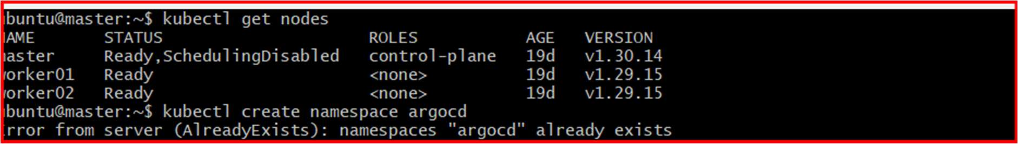
2. Install Argo CD
kubectl create namespace argocd
kubectl apply -n argocd --server-side --force-conﬂicts \
-f https://raw.githubusercontent.com/argoproj/argo-cd/stable/manifests/install.yaml

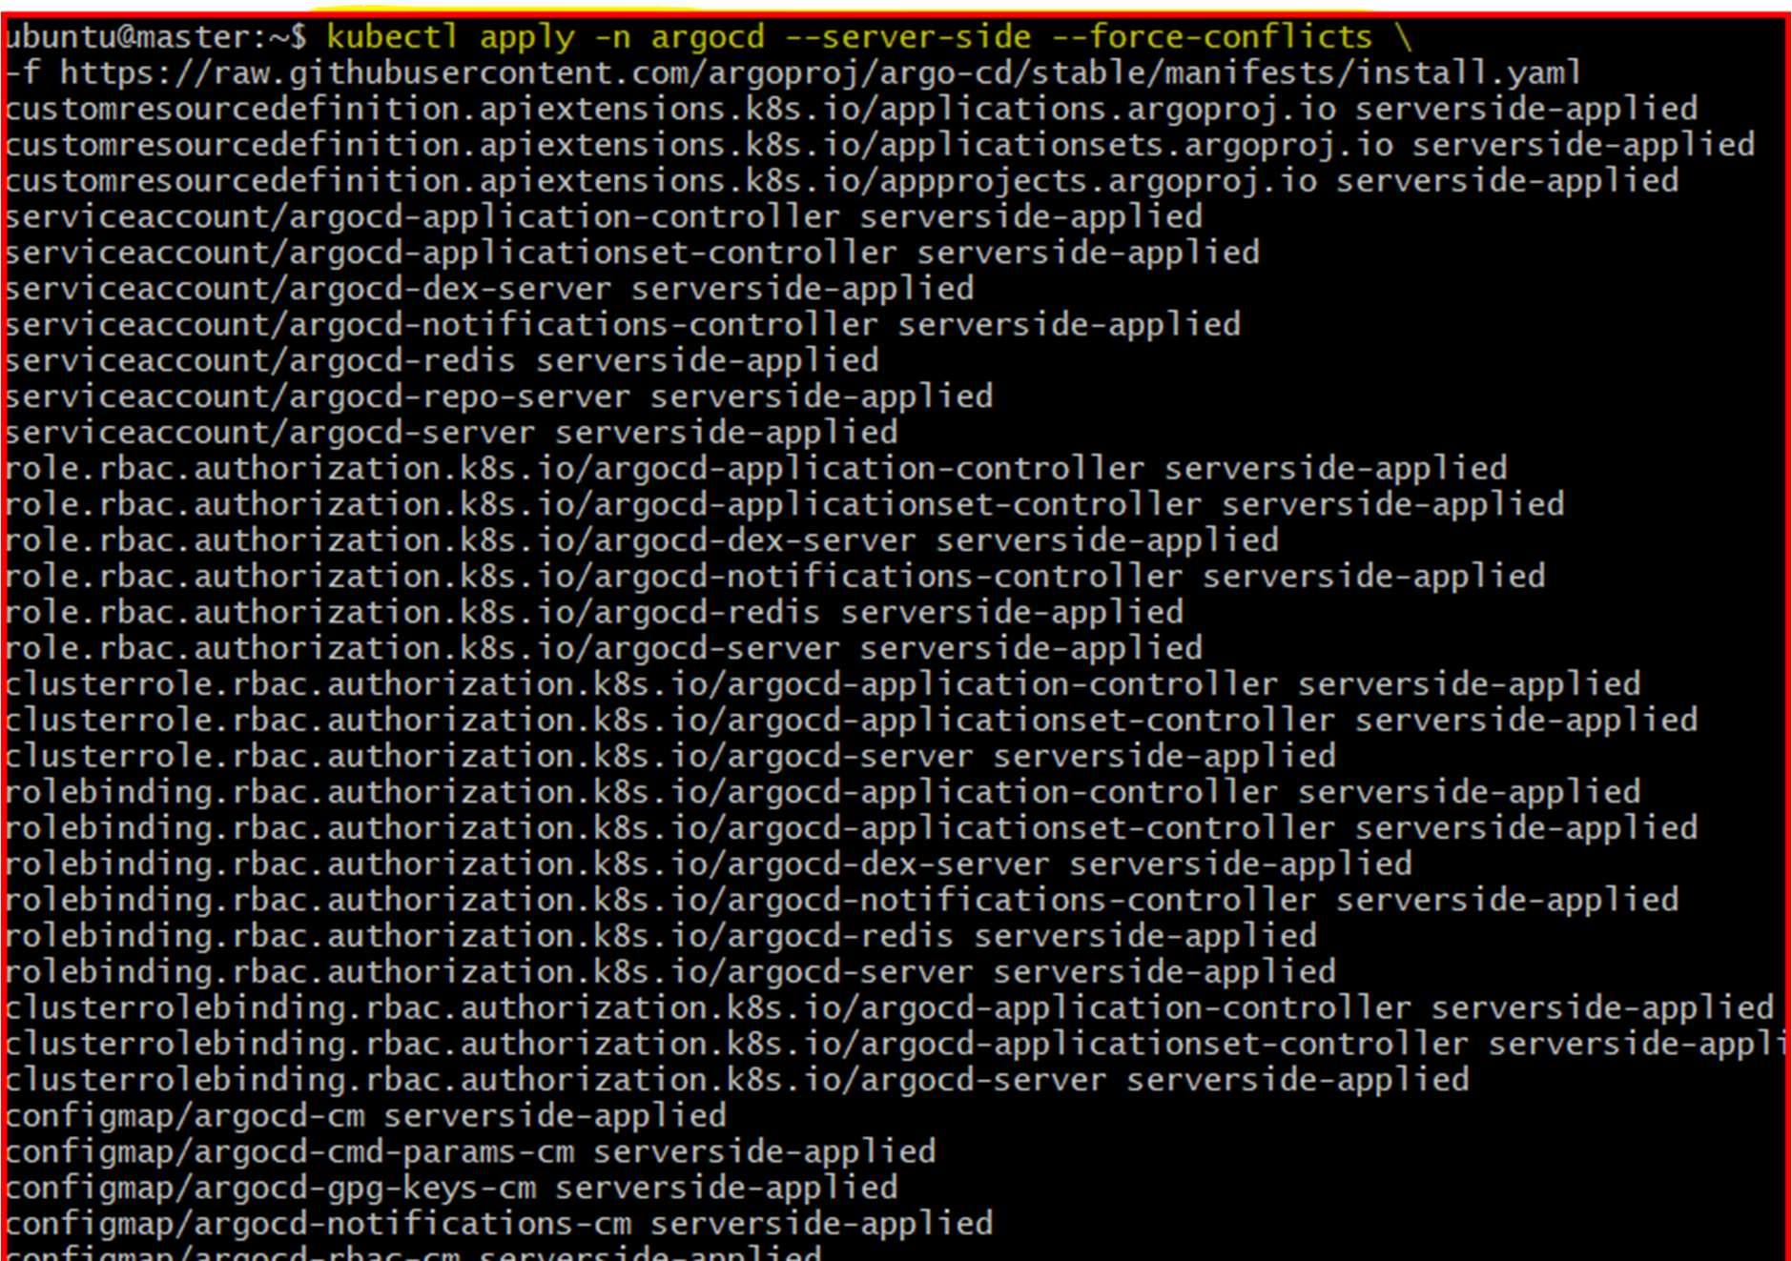
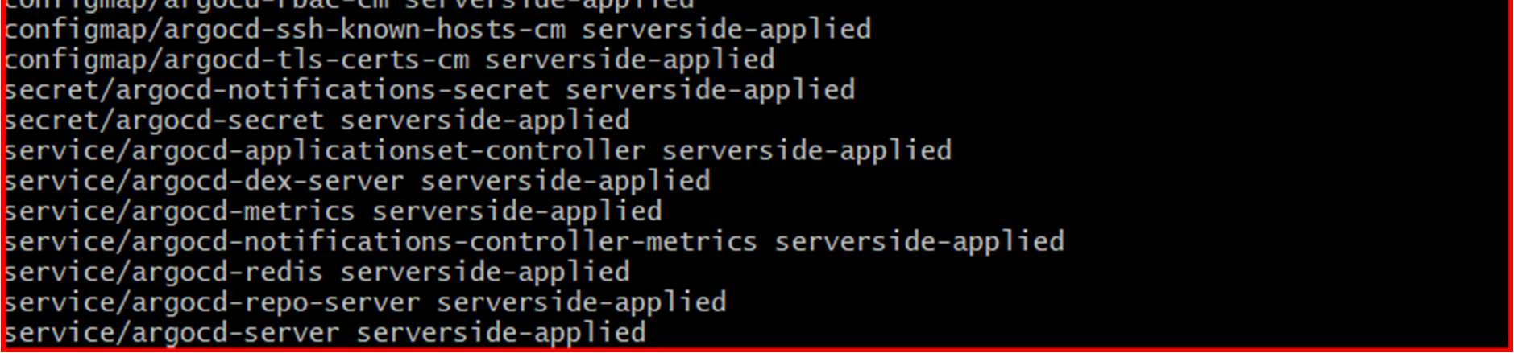
3. Check pods
kubectl get pods -n argocd
Wait until all pods show Running.
kubectl get svc -n argocd
Expose Argo CD UI using LoadBalancer
For EKS:

kubectl patch svc argocd-server -n argocd \
-p '{"spec": {"type": "LoadBalancer"}}'
Check URL:
kubectl get svc argocd-server -n argocd
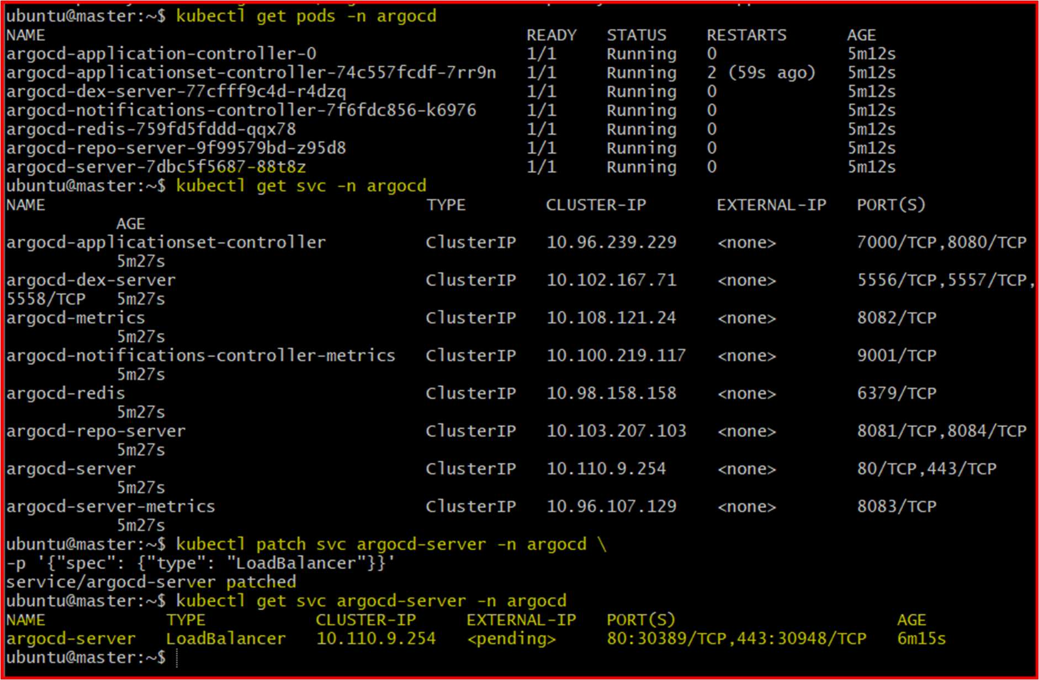
Step 6 — Get Initial Admin Password
Username:
admin
Get password:
kubectl get secret argocd-initial-admin-secret \
-n argocd \
-o jsonpath="{.data.password}" | base64 –d

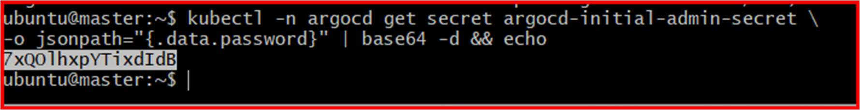
Copy password.
Step 7 — Login to Argo CD UI
Open:
https://<ARGOCD-URL>
https://a742141a7854041418eced4bb61eae15-1709993908.eu-north-
1.elb.amazonaws.com/applications
Login:
Username: admin
Password: <copied-password> bdTVEDC0oHQ-HXwd
2. Create Jenkins job for CI.
I have installed docker and pulled images of Jenkins, sonarqube and nexus in master node.
1. Install Docker
Update packages
sudo apt update

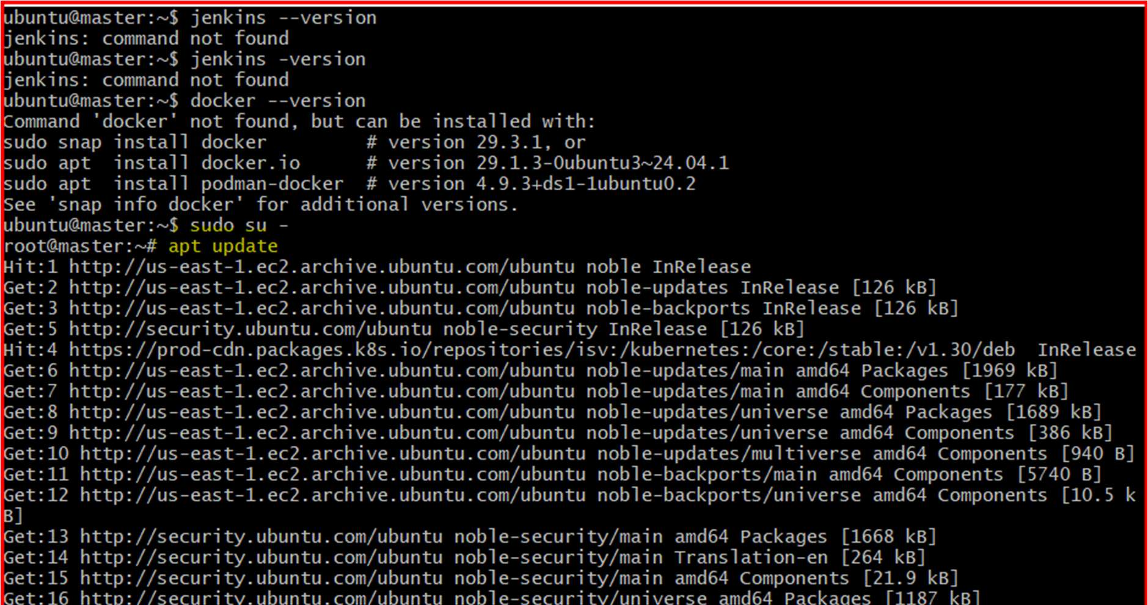
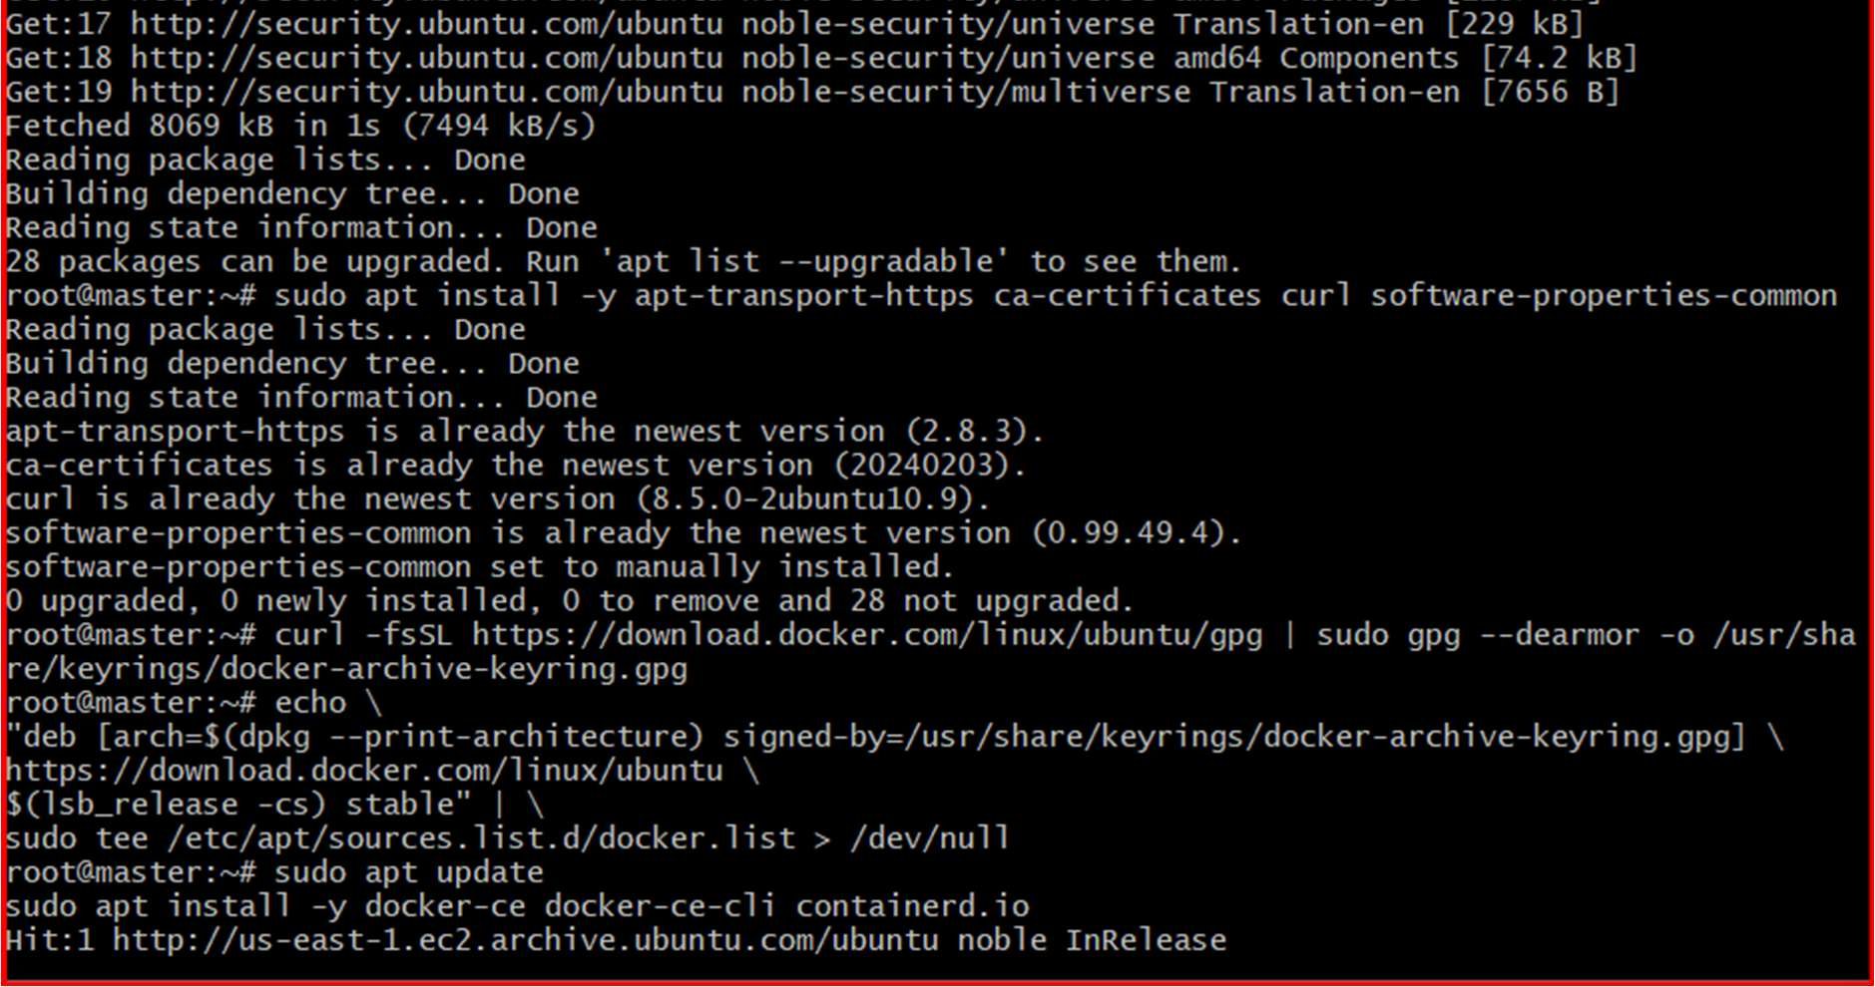
Install required packages
sudo apt install -y apt-transport-https ca-certiﬁcates curl software-properties-common
Add Docker GPG key
curl -fsSL https://download.docker.com/linux/ubuntu/gpg | sudo gpg --dearmor -o
/usr/share/keyrings/docker-archive-keyring.gpg

Add Docker repository
echo \
"deb [arch=$(dpkg --print-architecture) signed-by=/usr/share/keyrings/docker-archive-
keyring.gpg] \
https://download.docker.com/linux/ubuntu \
$(lsb_release -cs) stable" | \
sudo tee /etc/apt/sources.list.d/docker.list > /dev/null
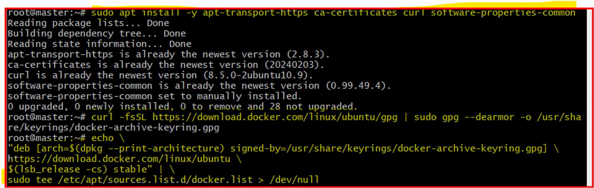

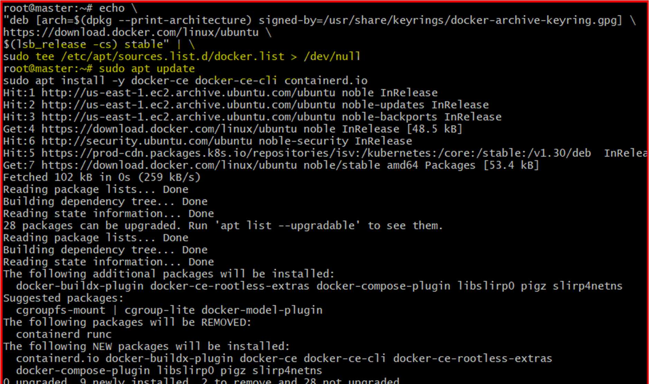
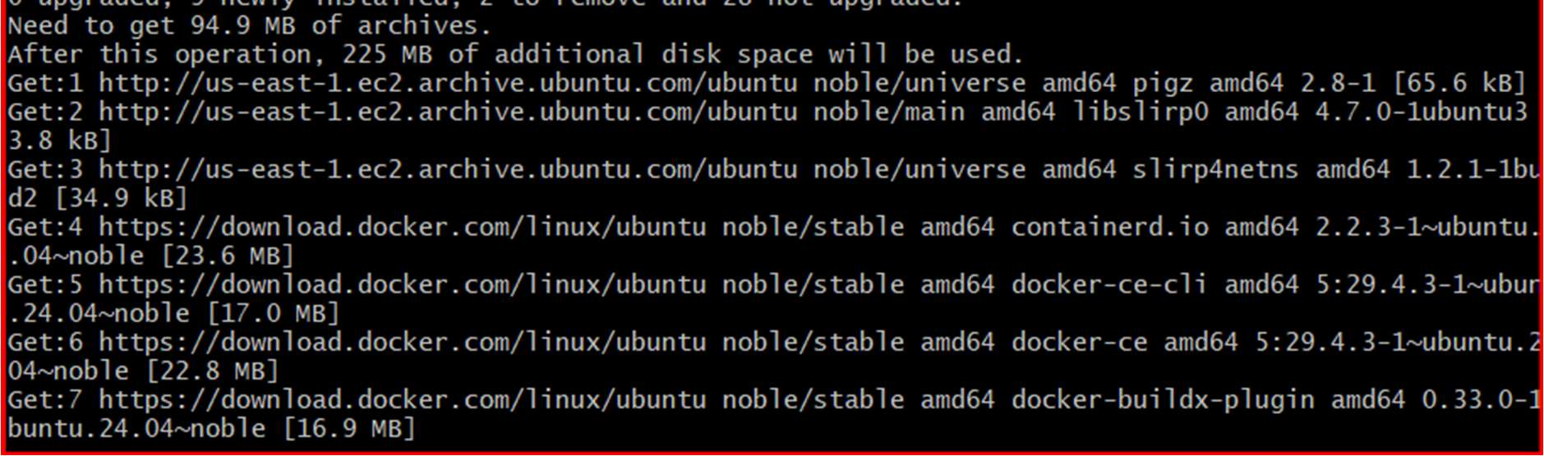
Install Docker
sudo apt update
sudo apt install -y docker-ce docker-ce-cli containerd.io
Start and enable Docker
sudo systemctl enable docker
sudo systemctl start docker
Verify Docker

docker --version
Expected:
Docker version xx.x.x
蠷
 2. Allow Current User to Run Docker
sudo usermod -aG docker $USER
newgrp docker
Verify:
docker ps
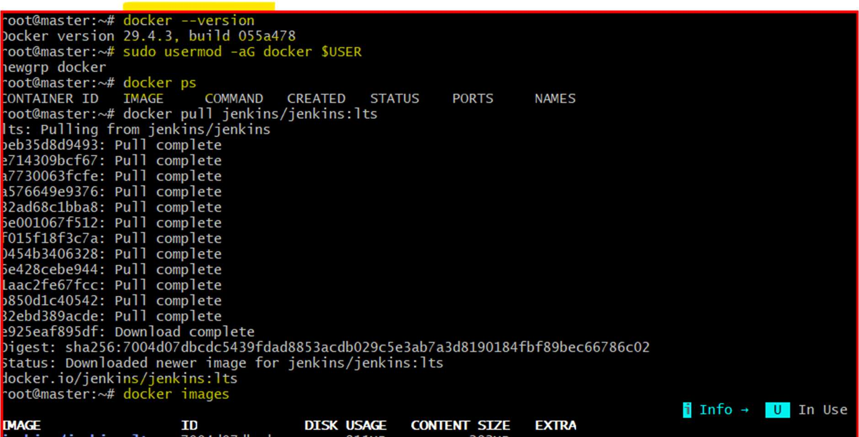
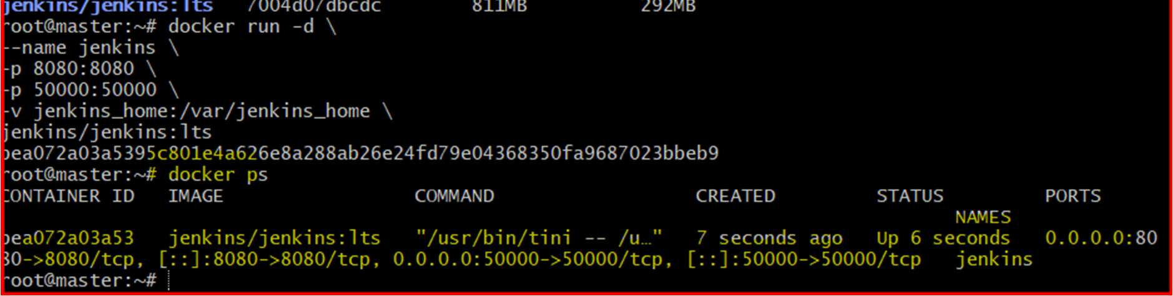

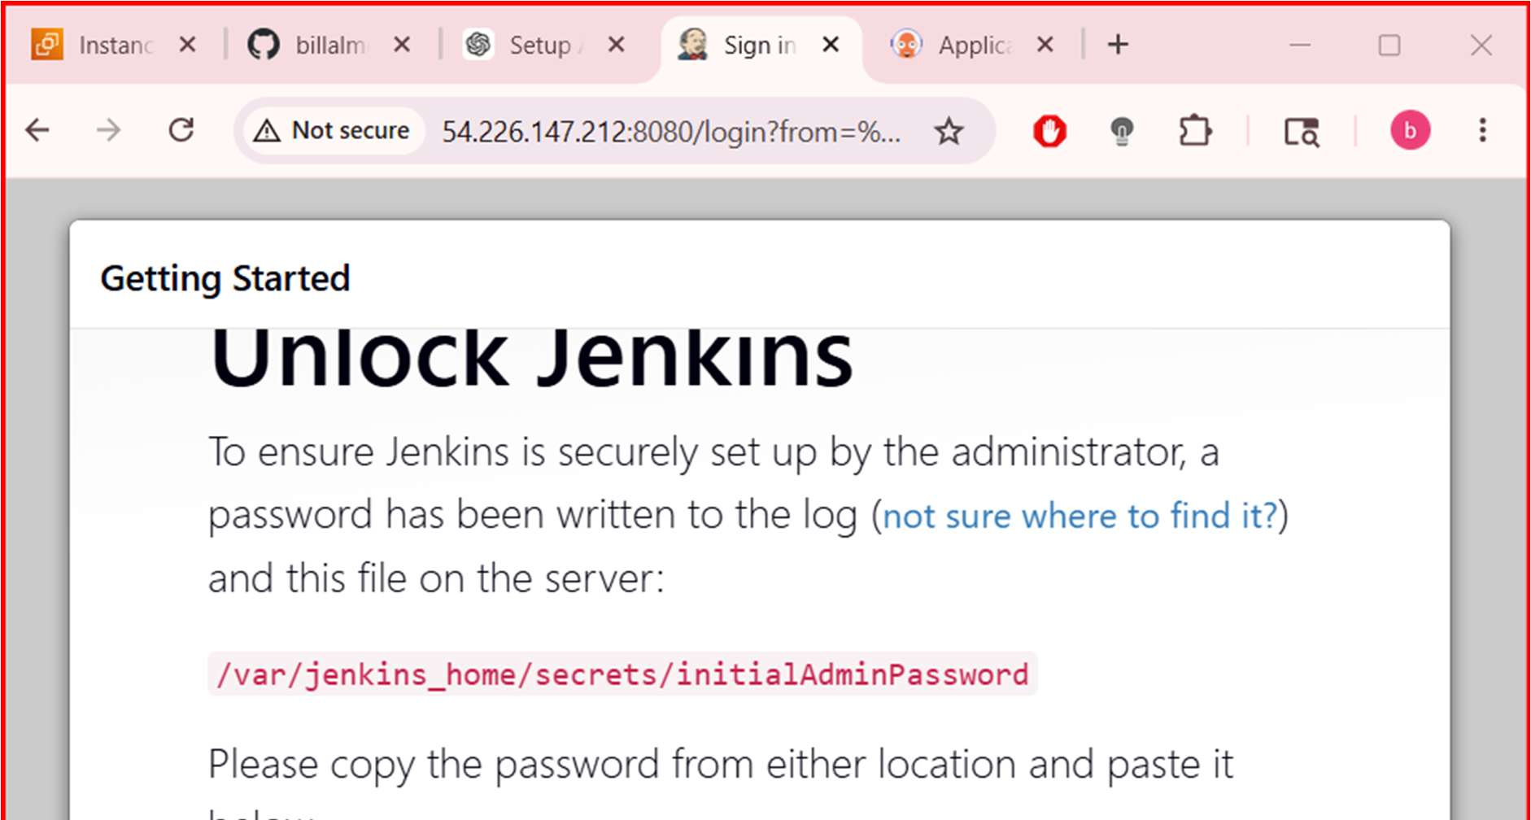
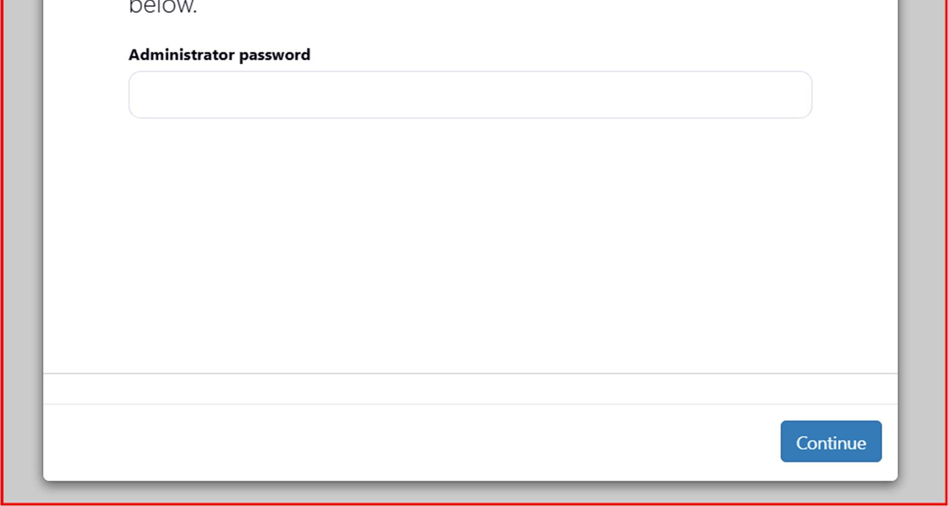
3. Pull Jenkins Image
Using oƯicial Jenkins image:
docker pull jenkins/jenkins:lts
Verify:
docker images
4. Run Jenkins Container
docker run -d \
--name jenkins \
-p 8080:8080 \
-p 50000:50000 \
-v jenkins_home:/var/jenkins_home \
jenkins/jenkins:lts
Check:
docker ps

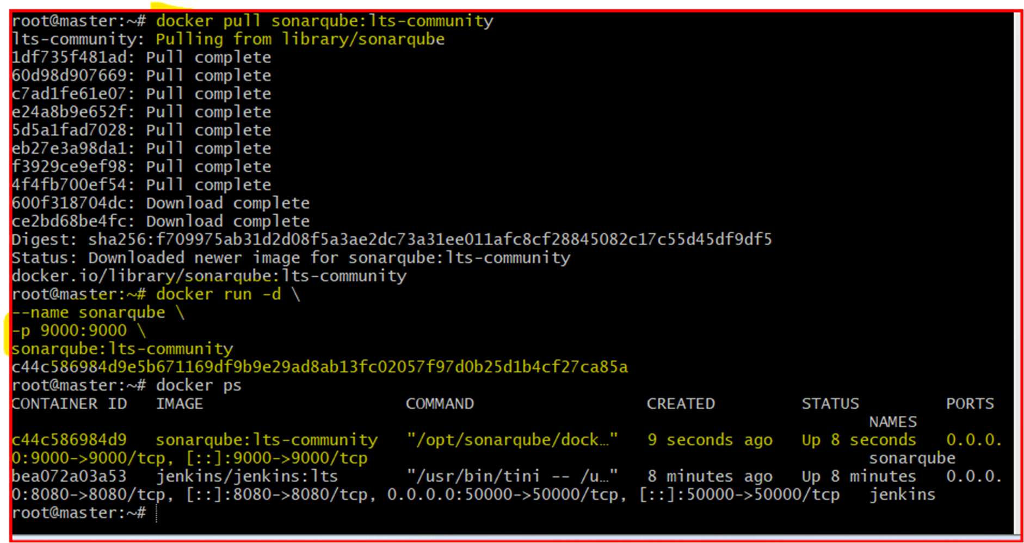

Get Jenkins Admin Password
docker exec jenkins cat /var/jenkins_home/secrets/initialAdminPassword
Access:
http://<SERVER-IP>:8080

5. Pull SonarQube Image
Using oƯicial SonarQube image:
docker pull sonarqube:lts-community
6. Run SonarQube Container
docker run -d \
--name sonarqube \
-p 9000:9000 \
sonarqube:lts-community
Check:
docker ps
Access:
http://<SERVER-IP>:9000
Default login:
admin / admin
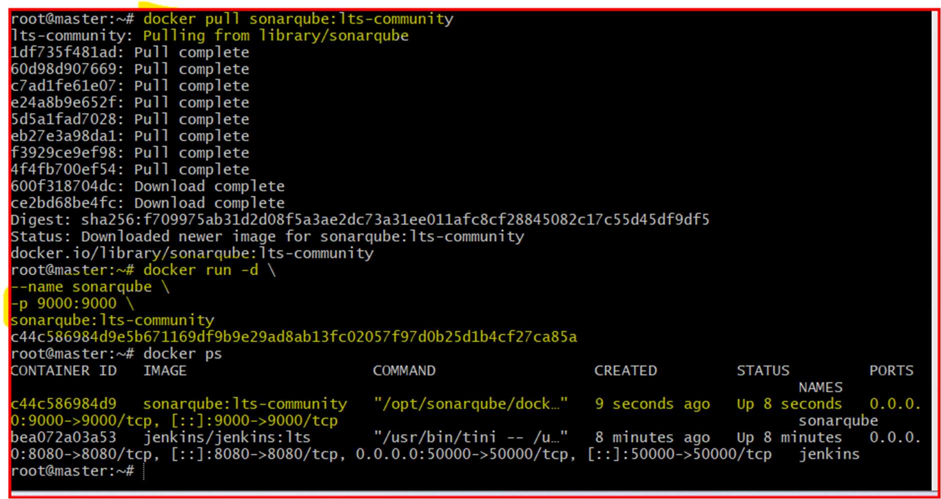

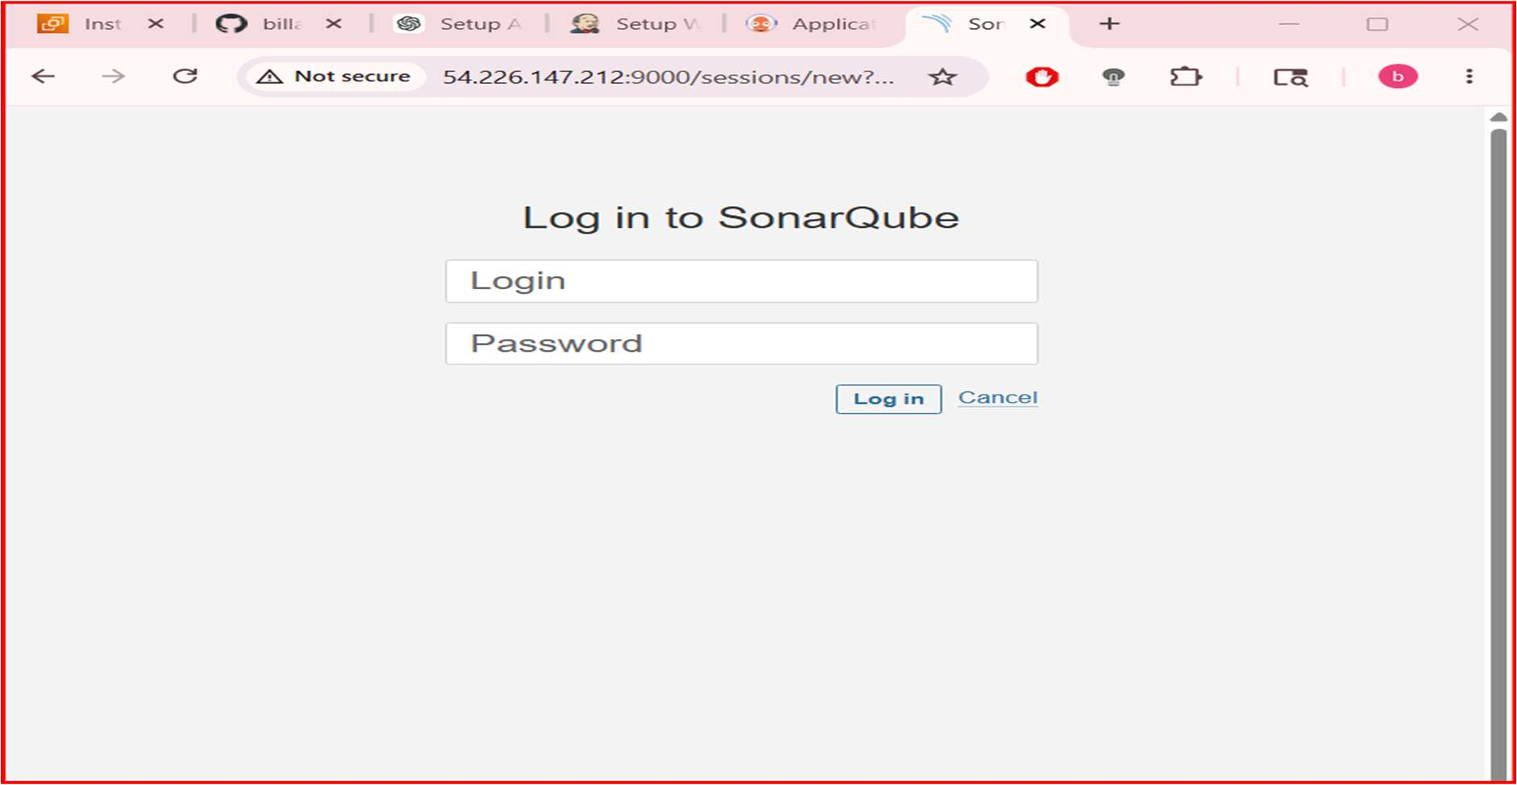
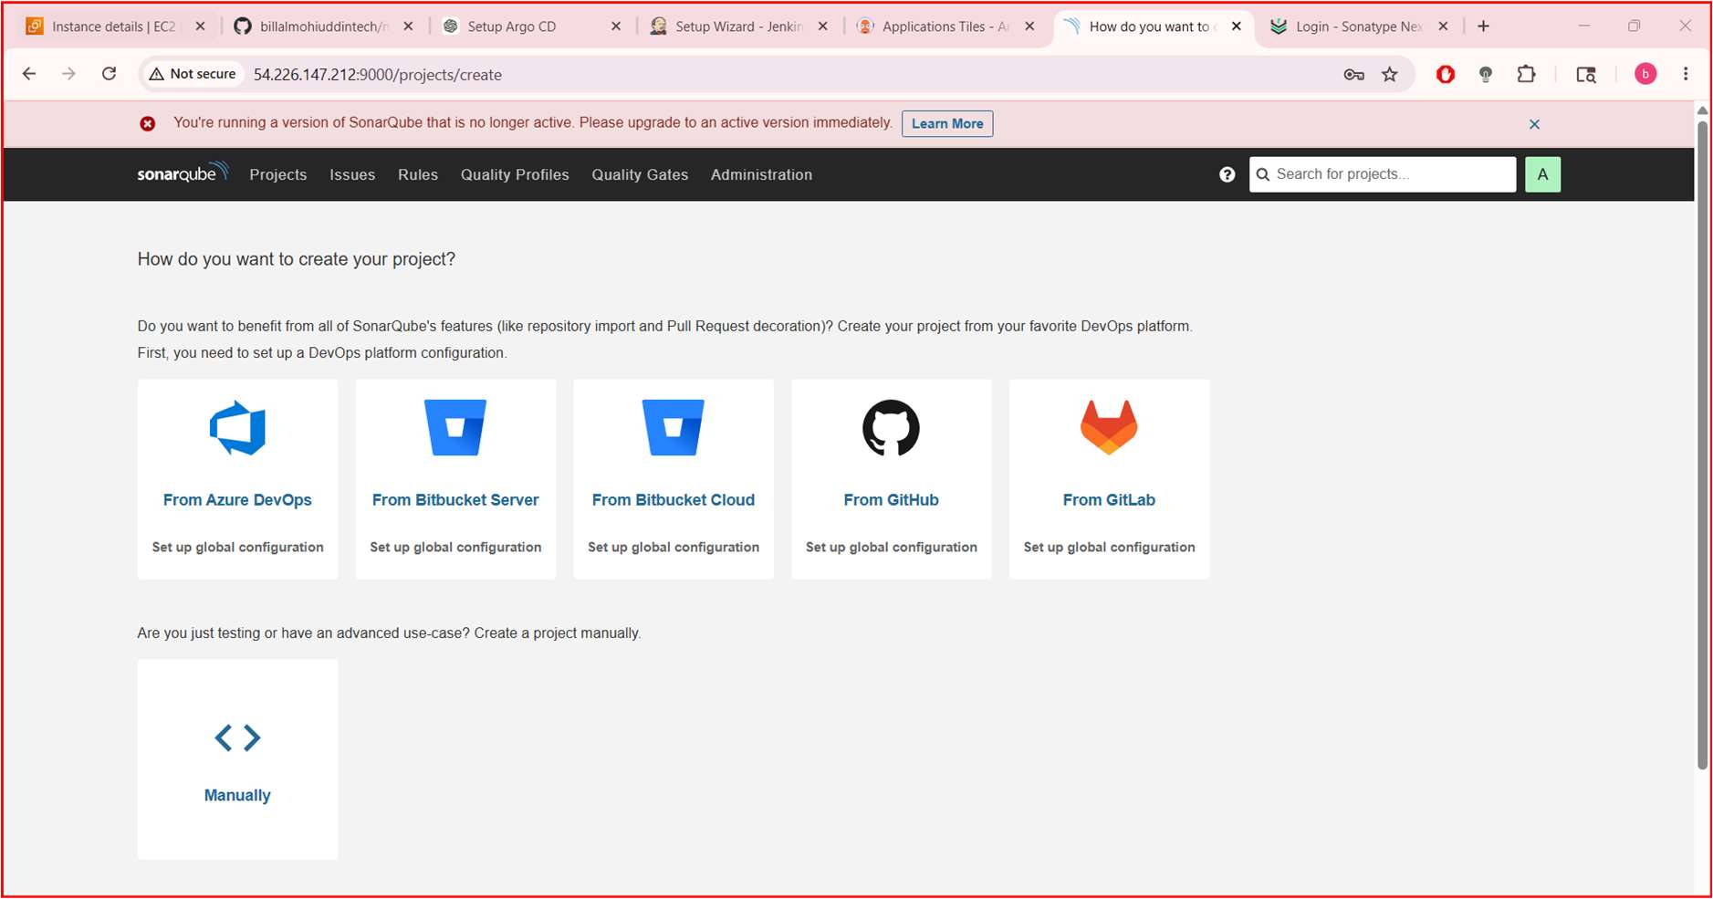

7. Pull Nexus Image
Using oƯicial Nexus Repository image:
docker pull sonatype/nexus3
8. Run Nexus Container
docker run -d \
--name nexus \
-p 8081:8081 \
-v nexus-data:/nexus-data \
sonatype/nexus3
Check:
docker ps
Access:
http://<SERVER-IP>:8081

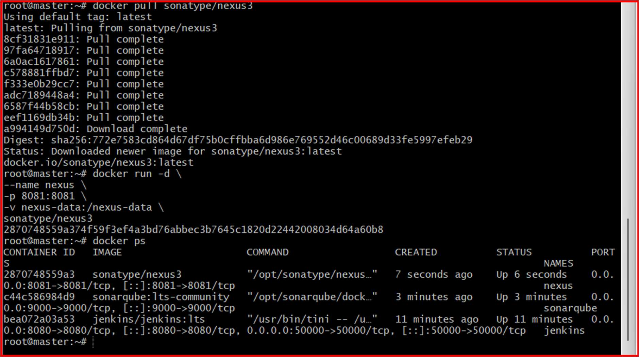
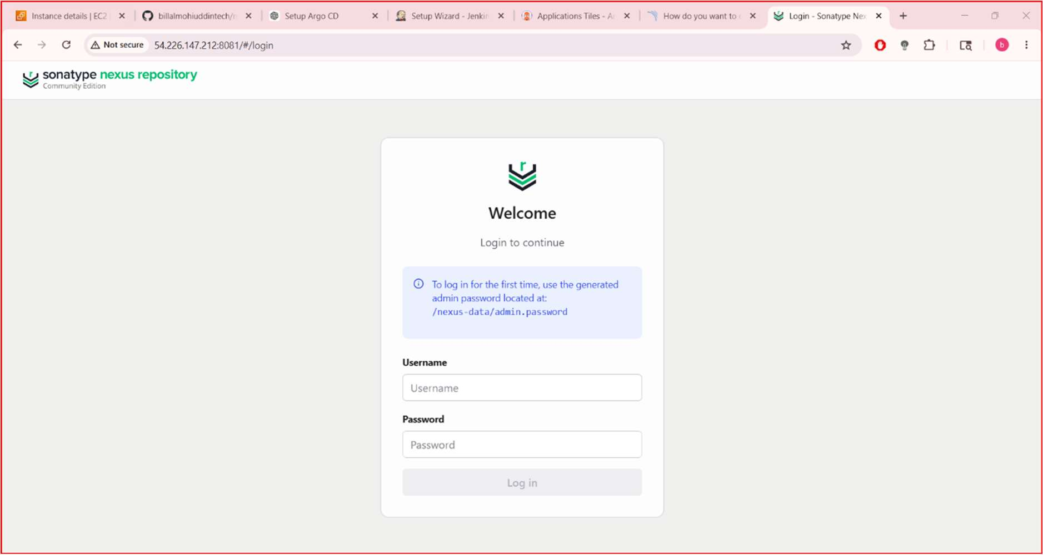

 Get Nexus Admin Password
Wait 2–3 minutes for startup, then:
docker exec nexus cat /nexus-data/admin.password
Username:
Admin
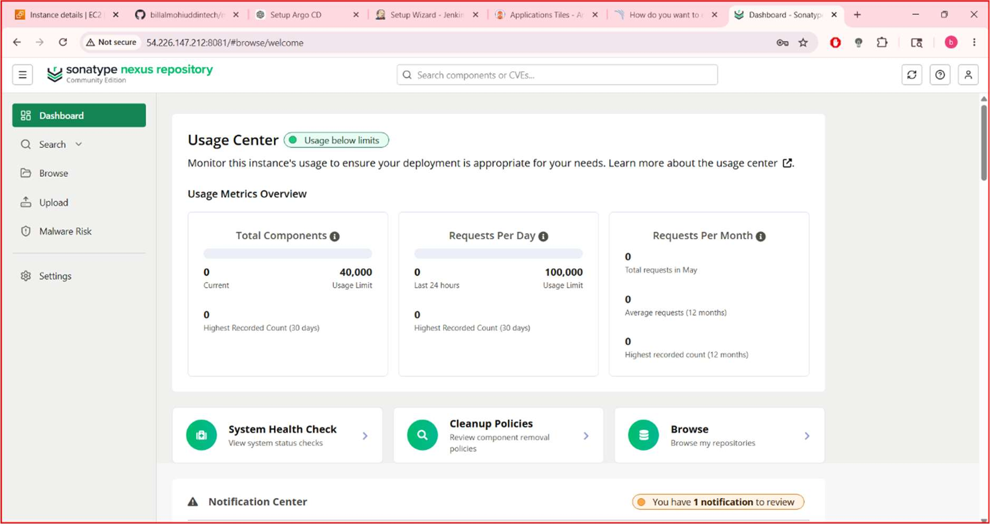
Verify All Containers
docker ps
Expected:
jenkins
sonarqube
nexus

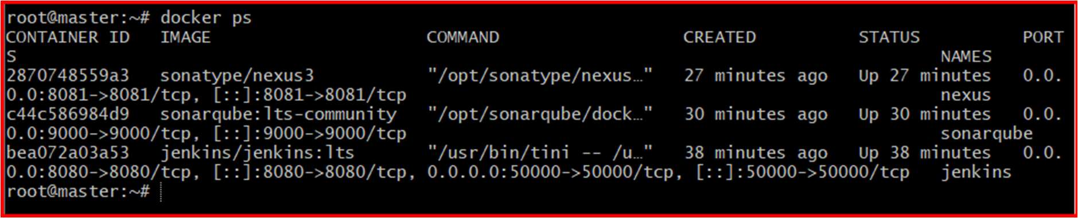
STEP 5: Install Maven + Docker Inside Jenkins
Enter Jenkins container:
docker exec -u 0 -it jenkins bash
Update packages:
apt update
Install required tools:
apt install -y default-jdk maven docker.io git
Verify:
mvn -version
docker --version
java -version
git --version
Exit:
Exit
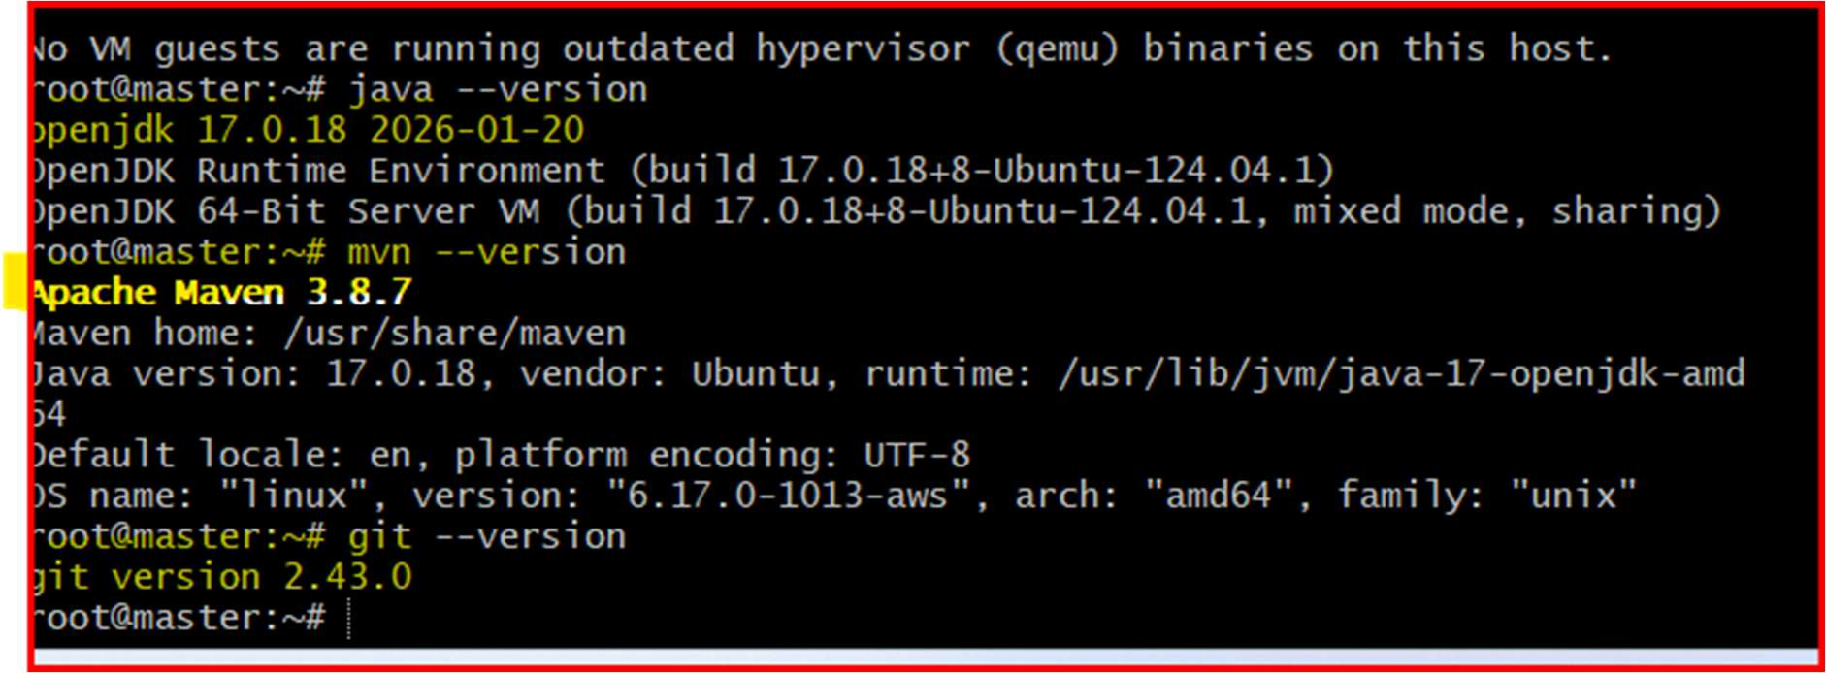

STEP 6: Conﬁgure Jenkins Tools
Go to:
Manage Jenkins → Tools
Conﬁgure JDK
Add JDK:
Field
Value
Name
jdk17
JAVA_HOME /usr/lib/jvm/java-17-openjdk-amd64
Uncheck:
Install automatically
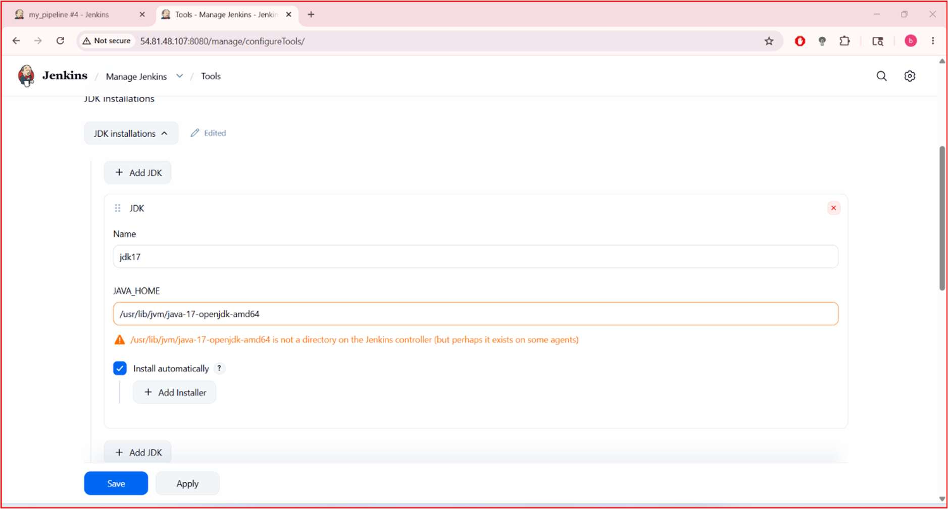
Conﬁgure Maven
Add Maven:

Field
Value
Name
maven3
MAVEN_HOME /usr/share/maven
Uncheck:
Install automatically
Save
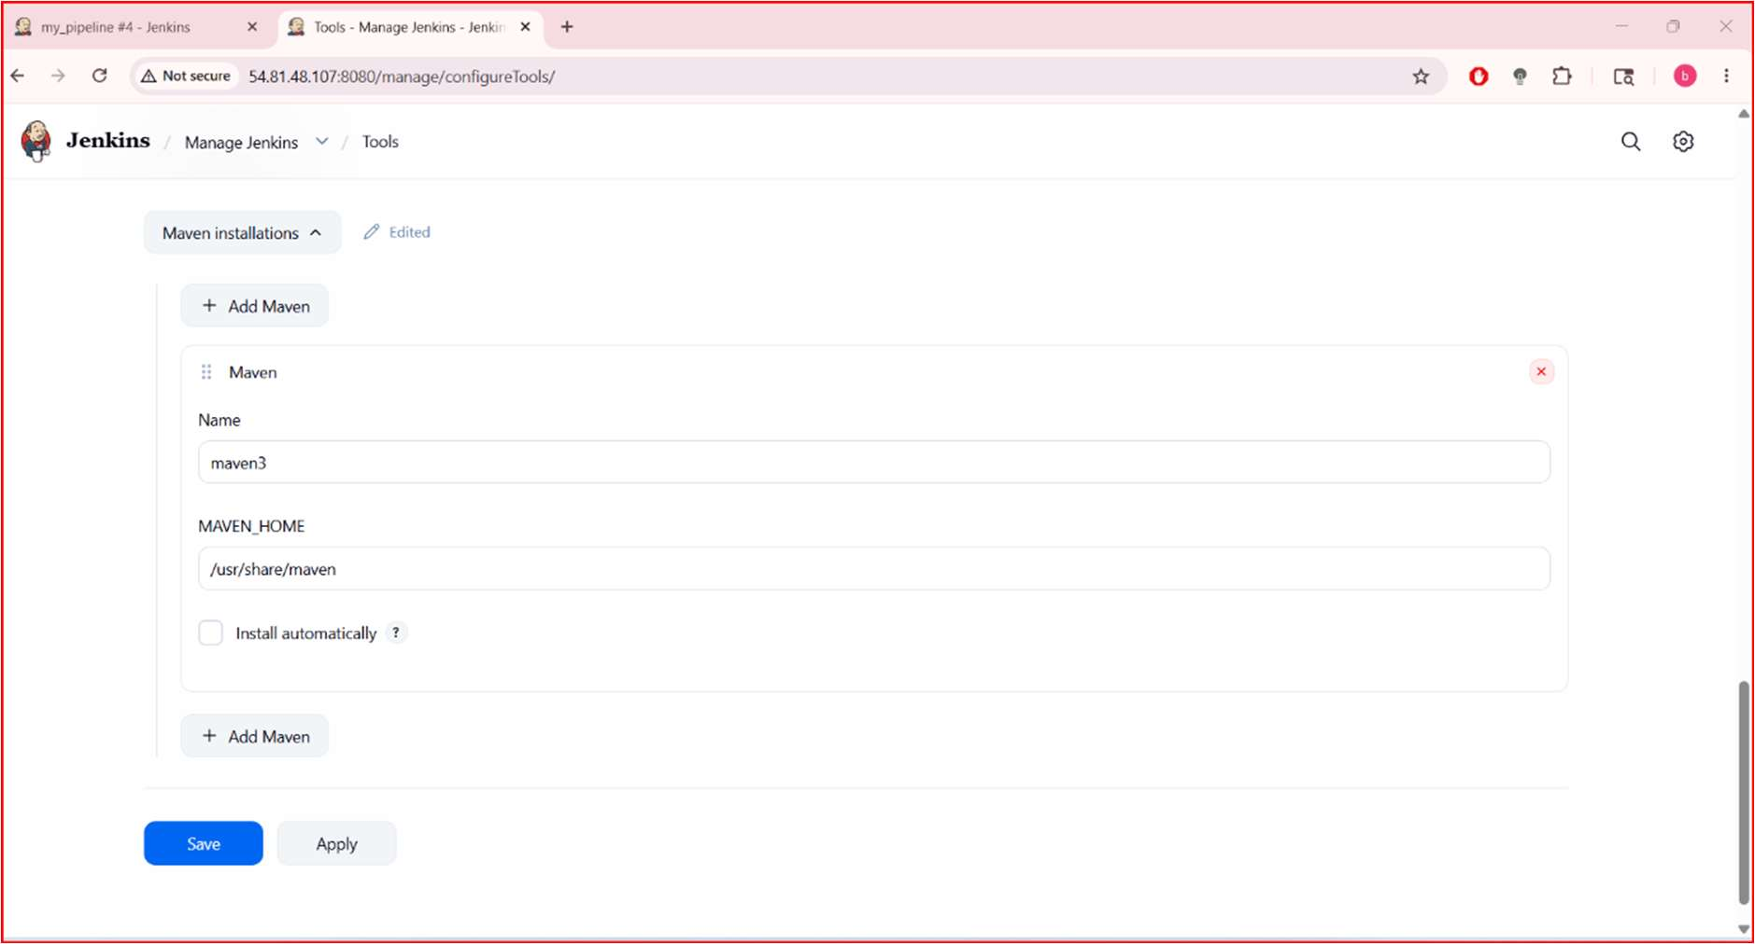

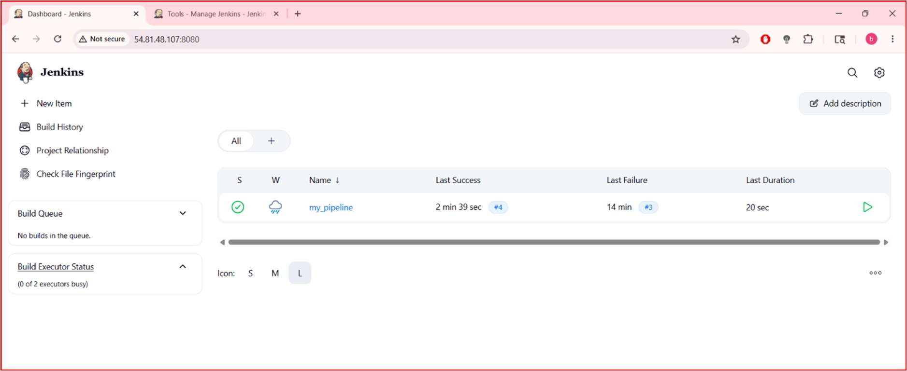
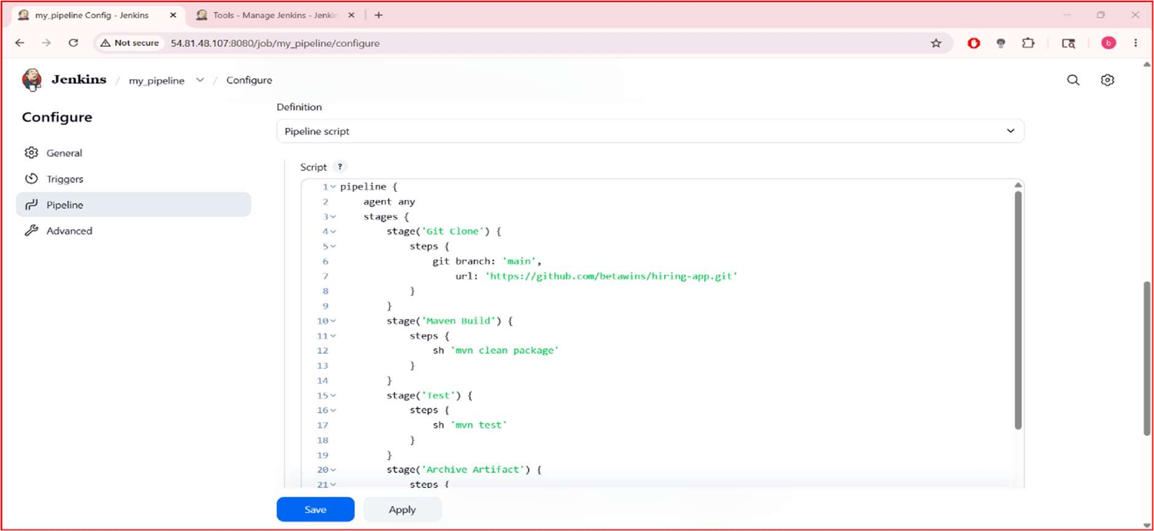

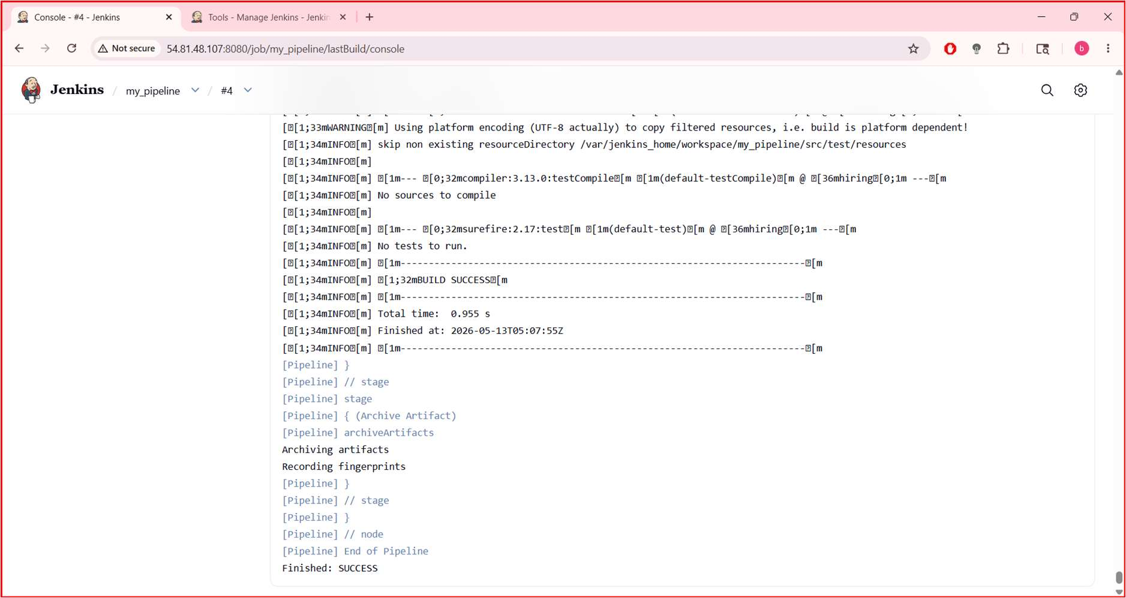
STEP 7: Prepare GitHub Repository
Your GitHub repo must contain:
pom.xml
src/
Dockerﬁle
STEP 7: Prepare GitHub Repository
Your GitHub repo must contain:
pom.xml
src/
Dockerﬁle
Move into repo:
cd hiring-app

Check ﬁles:
Ls
STEP 8: Create Dockerﬁle
STEP 2: Create Dockerﬁle
Run:
Nano Dockerﬁle
Press:
i
to enter insert mode.
Paste:
FROM tomcat:9
COPY target/*.war /usr/local/tomcat/webapps/
EXPOSE 8080
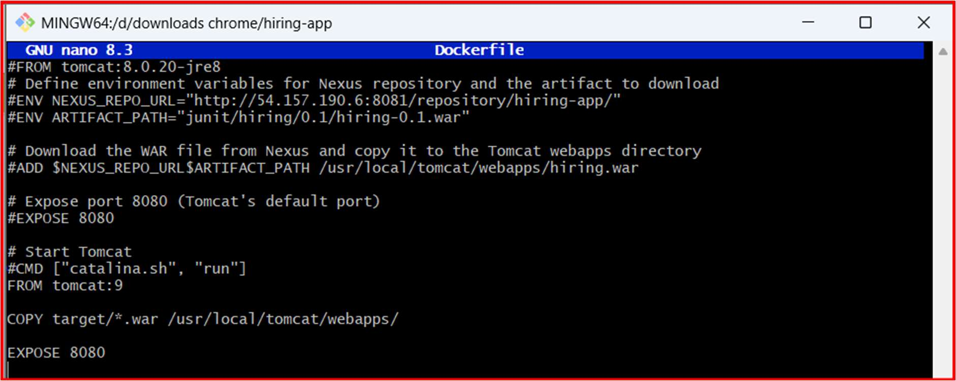
STEP 5: Push Dockerﬁle To GitHub
Check git status:

git status
Add ﬁle:
git add Dockerﬁle
Commit:
git commit -m "Added Dockerﬁle"
Push:
git push origin main
OPTION 1 (Recommended) → Fork Repo
Open:
https://github.com/betawins/hiring-app
Click:
Fork
This creates:
https://github.com/billalmohiuddintech/hiring-app.git
under your account
STEP 2: Change Git Remote
Inside project folder run:
git remote -v
Remove old remote:
git remote remove origin
Add your repo:
git remote add origin https://github.com/vigneshadlagatta1/hiring-app.git
Verify:
git remote -v

STEP 3: Push Code
Run:
git push -u origin main
GitHub may ask:
username
•
password/token
•
STEP 6: Verify In GitHub
Open repo:
https://github.com/betawins/hiring-app
You should now see:
Dockerﬁle
inside repo root directory
STEP 9: Create Jenkins Pipeline Job
Go to Jenkins dashboard.
Click:
New Item
Name:
docker-build-pipelinejob
Select:
Pipeline
Click OK.

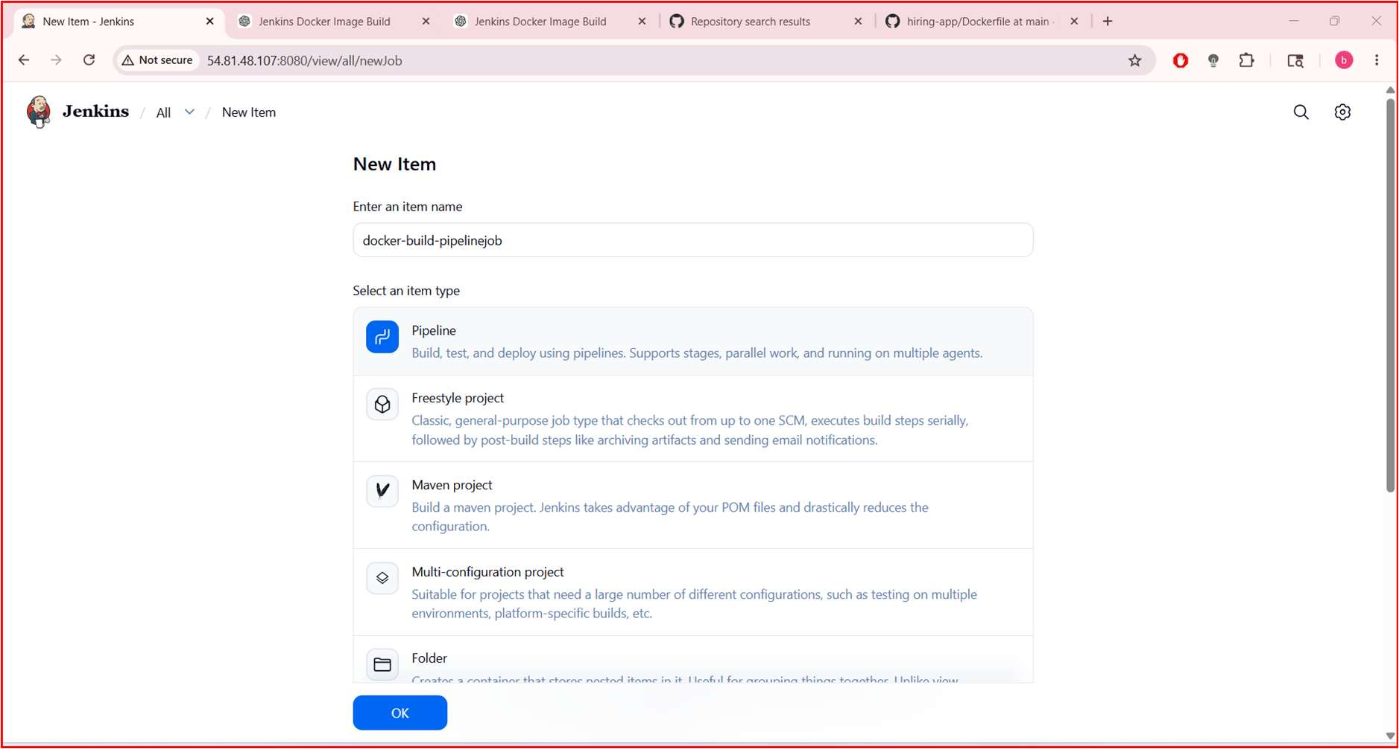
STEP 10: Add Pipeline Script
Go to:
Pipeline → Deﬁnition → Pipeline Script
Paste:
pipeline {
agent any
tools {
jdk 'jdk17'
maven 'maven3'
}
environment {
IMAGE_NAME = "hiring-app"
IMAGE_TAG = "v1"
}
stages {

stage('Git Clone') {
steps {
git branch: 'main',
url: 'https://github.com/vigneshadlagatta1/hiring-app.git'
}
}
stage('Maven Build') {
steps {
sh 'mvn clean package'
}
}
stage('Run Tests') {
steps {
sh 'mvn test'
}
}
stage('Build Docker Image') {
steps {
sh 'docker build -t $IMAGE_NAME:$IMAGE_TAG .'
}
}
stage('Verify Docker Image') {
steps {
sh 'docker images'
}
}

}
post {
success {
echo 'Docker Image Built Successfully'
}
failure {
echo 'Build Failed'
}
}
}
Save.
STEP 11: Build Job
Click:
Build Now
STEP 12: Check Console Output
Open:
Build History → Console Output
You should see:
BUILD SUCCESS
and:
Successfully tagged hiring-app:v1

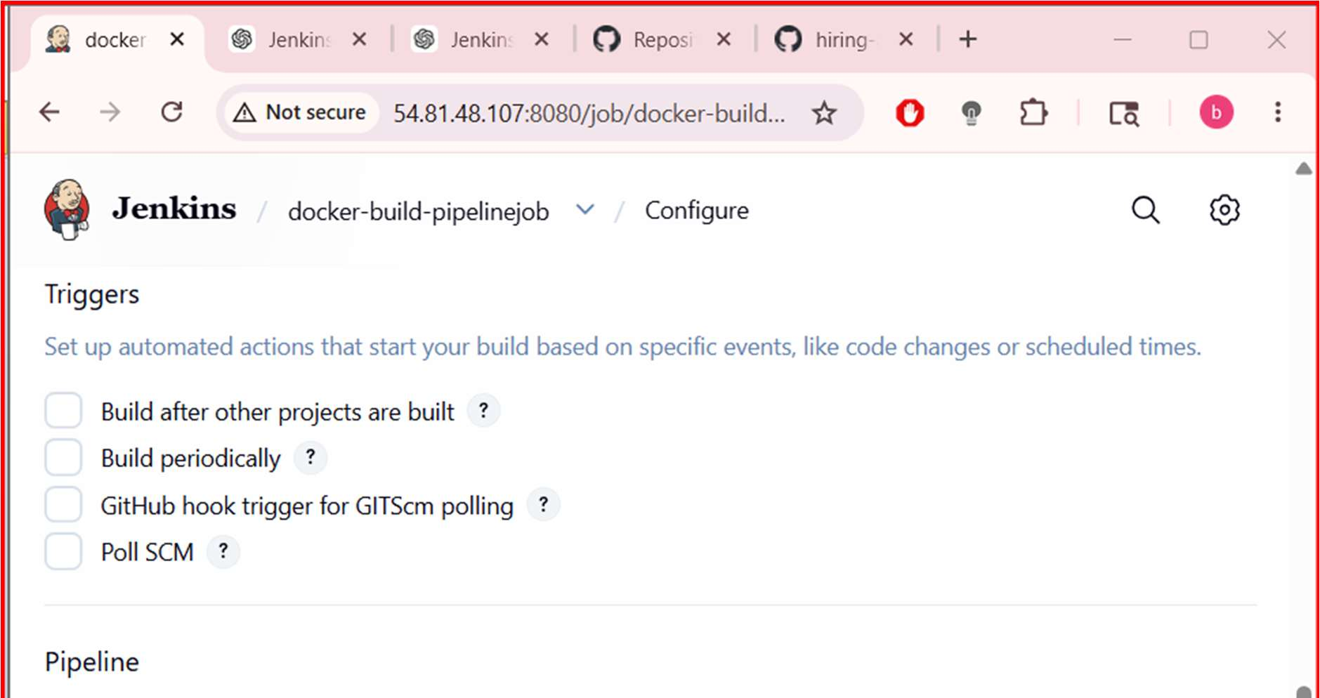
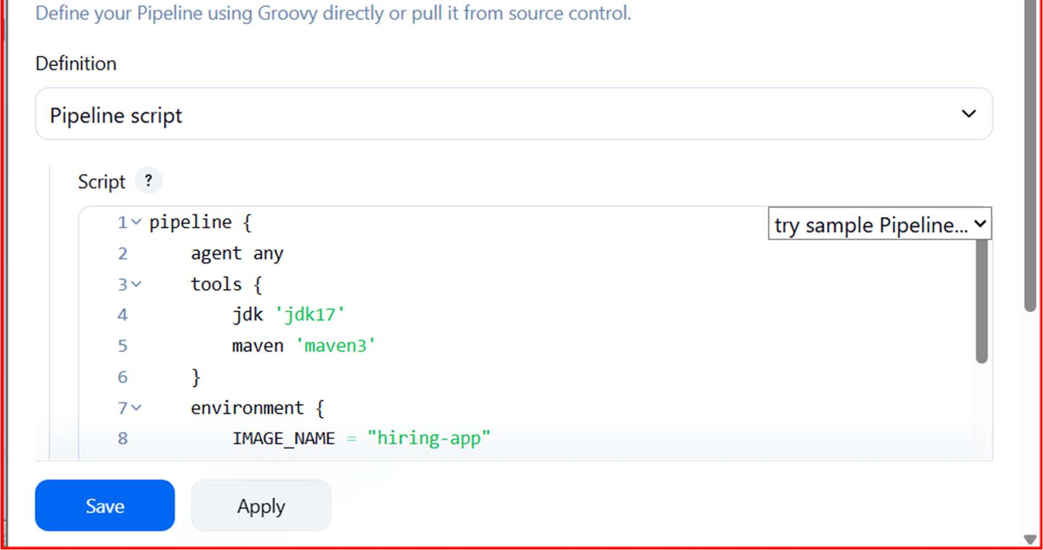

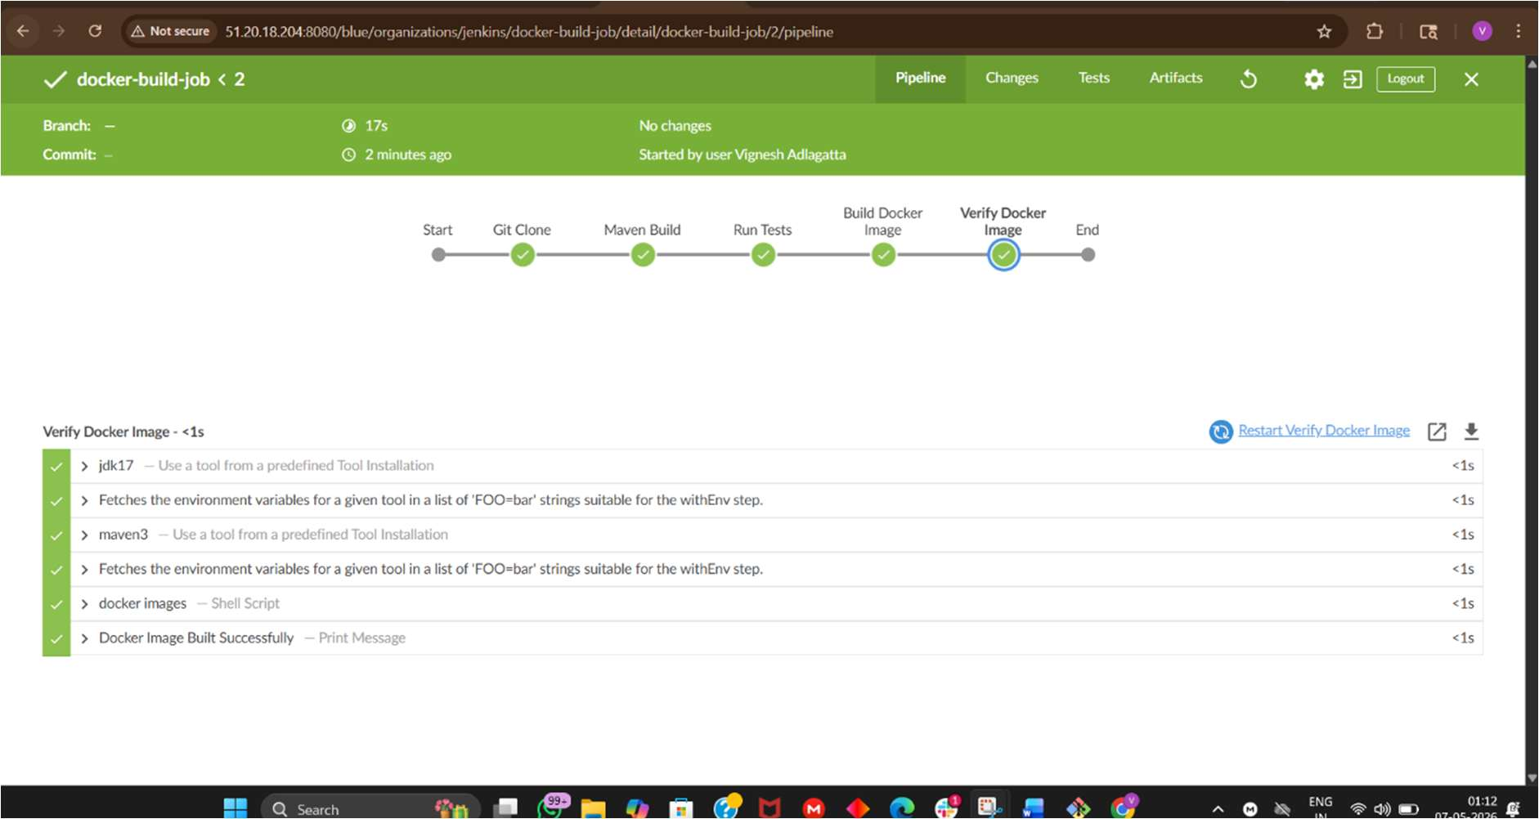
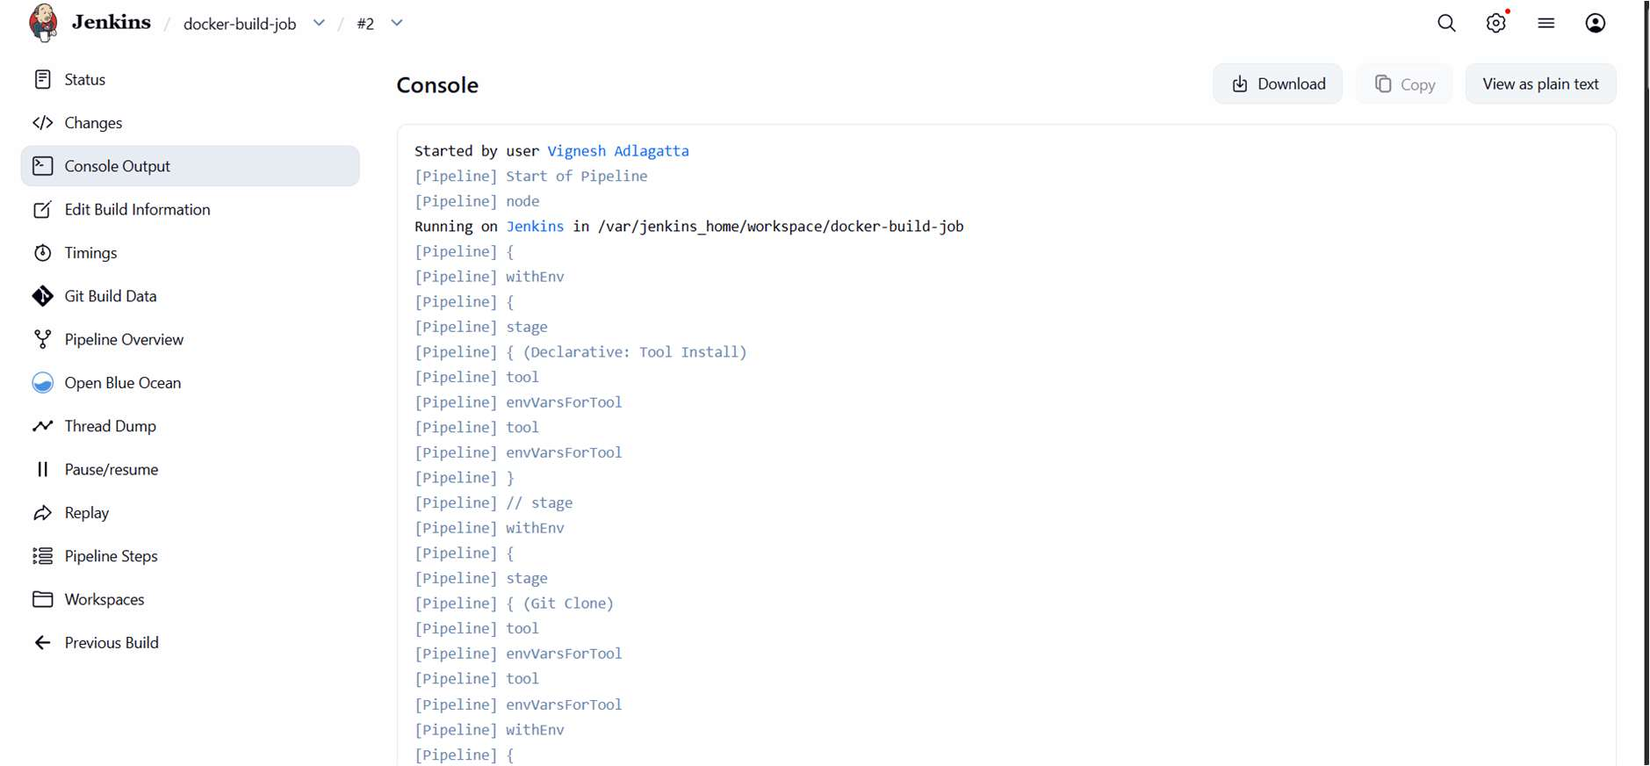

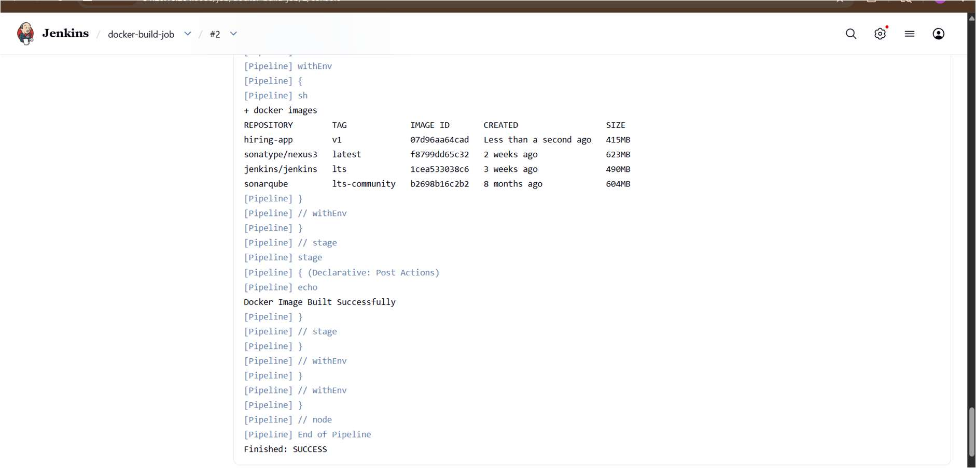
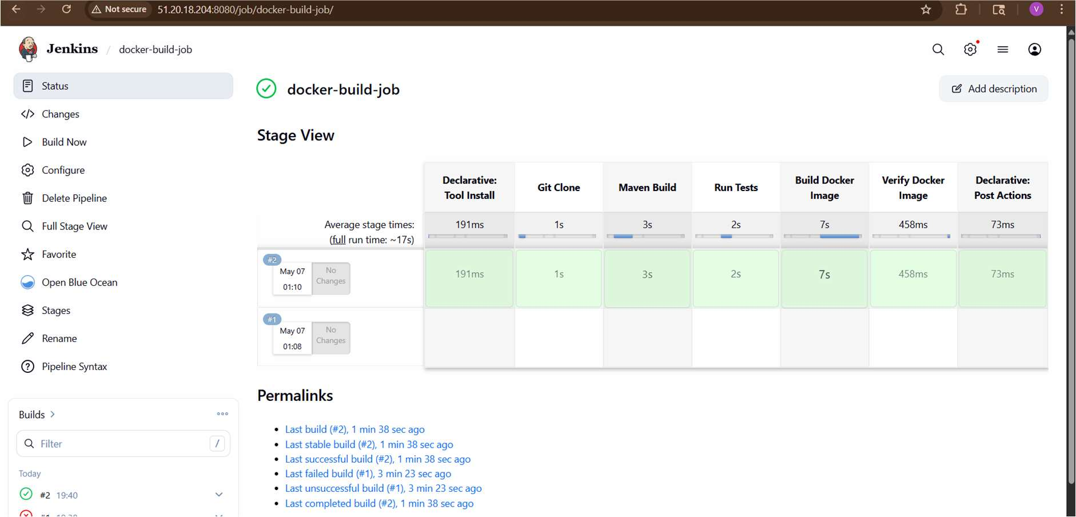
STEP 13: Verify Docker Image On EC2
Run:
docker images
You should see:
hiring-app v1
STEP 14: Run Docker Container

docker run -d \
--name hiring-container \
-p 8090:8080 \
hiring-app:v1
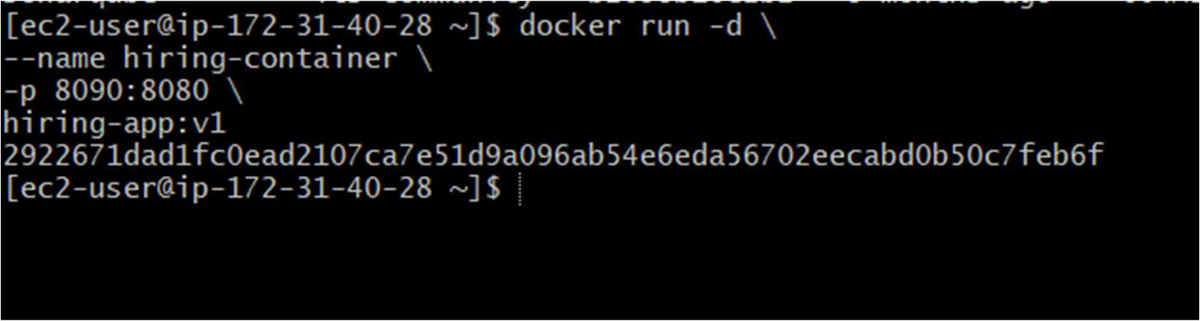
Verify:
docker ps
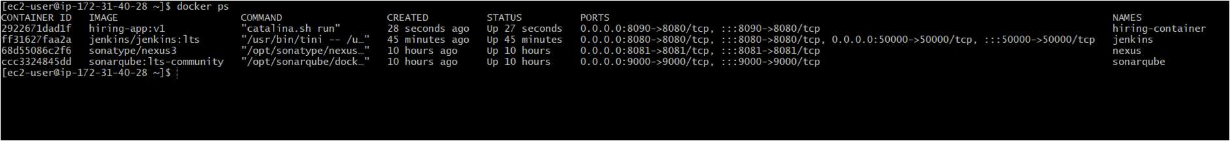
STEP 15: Access Application
Open browser:
http://<EC2-PUBLIC-IP>:8090
Example:
If WAR ﬁle is:
hiring.war
then app URL becomes:
http://51.20.18.204:8090/hiring
NOT:
http://51.20.18.204:8090

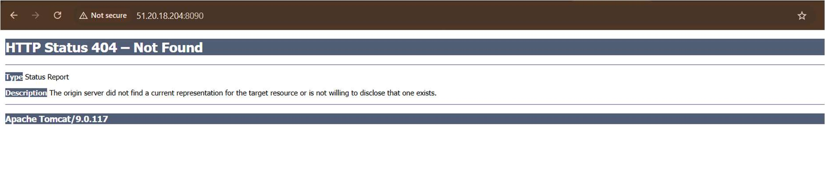

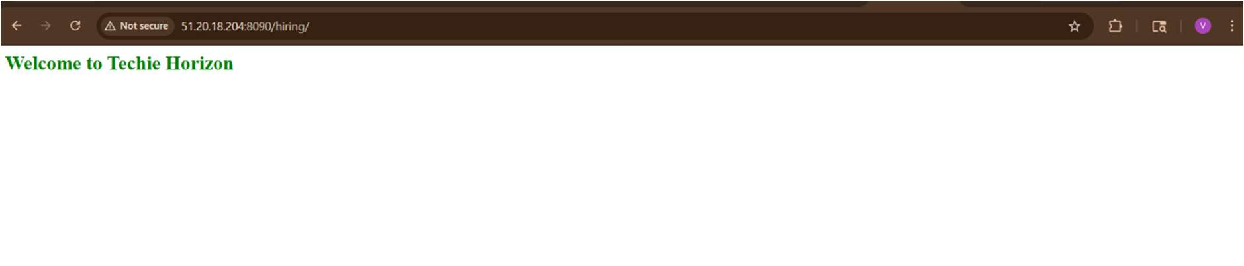
Your application should open
3. Create ArgoCD job to deploy on ek8s cluster
Now let’s build the next level:
Jenkins → DockerHub → ArgoCD → EKS
Goal:
GitHub
↓
Jenkins CI
↓
Docker Image
↓
DockerHub
↓
Kubernetes Manifest Repo
↓

ArgoCD
↓
EKS Cluster Deployment
STEP 1: Verify EKS Cluster Access
On EC2:
kubectl get nodes
You should see worker nodes.
If not conﬁgured:
aws conﬁgure
Then:
aws eks update-kubeconﬁg \
--region eu-north-1 \
--name demo-cluster
Verify:
kubectl get nodes
STEP 2: Install ArgoCD In EKS
Create namespace:
kubectl create namespace argocd
Install ArgoCD:
kubectl apply -n argocd -f https://raw.githubusercontent.com/argoproj/argo-
cd/stable/manifests/install.yaml
Wait 2 minutes.
Check pods:
kubectl get pods -n argocd
All should become:

Running
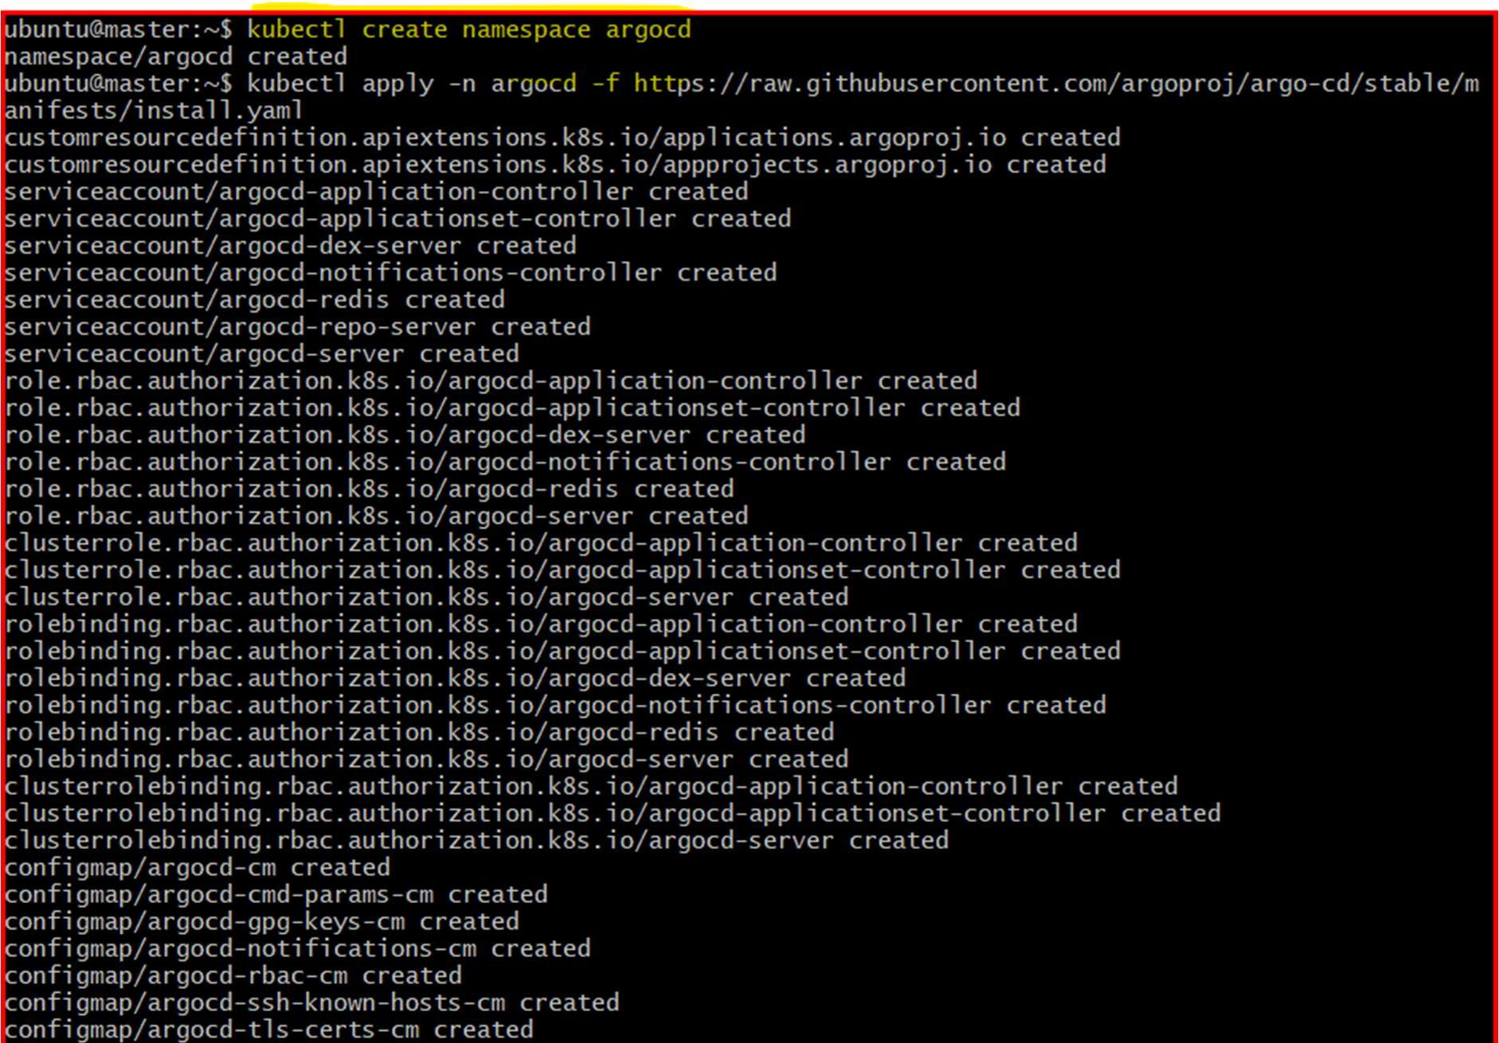
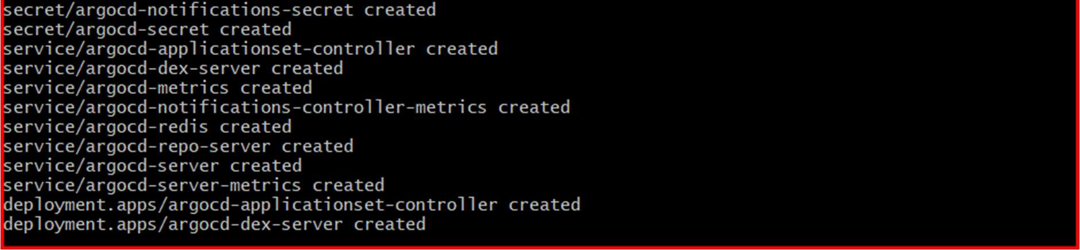
STEP 3: Expose ArgoCD Server
Run:
kubectl patch svc argocd-server -n argocd \
-p '{"spec": {"type": "LoadBalancer"}}'
Check external IP:
kubectl get svc -n argocd
Look for:

argocd-server
Copy EXTERNAL-IP.
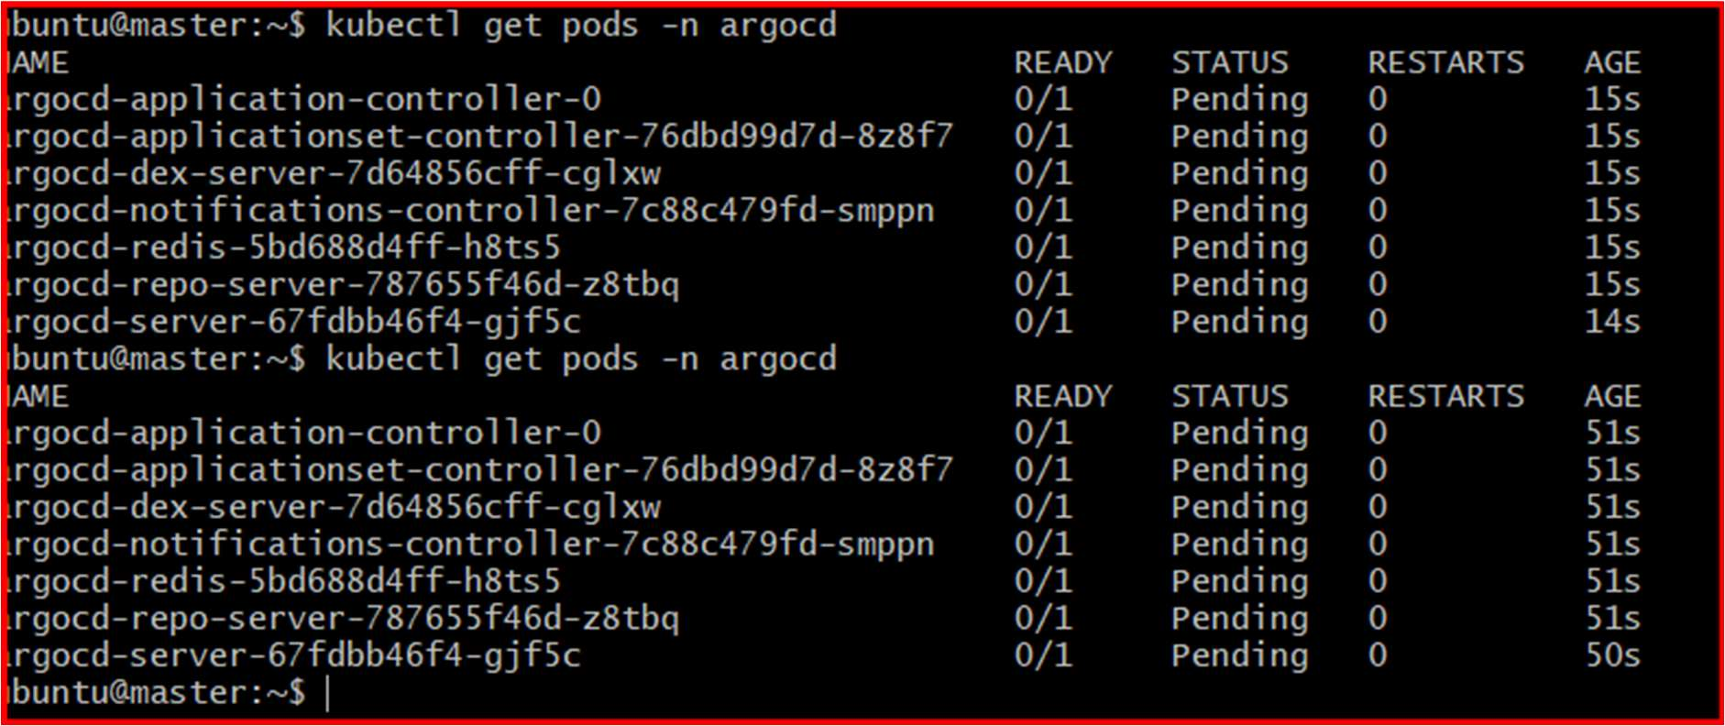
STEP 4: Get ArgoCD Password
Run:
kubectl get secret argocd-initial-admin-secret -n argocd \
-o jsonpath="{.data.password}" | base64 -d
Username:
admin
Password:
(output from above command)
STEP 5: Open ArgoCD UI
Browser:
https://<ARGOCD-EXTERNAL-IP>
Login:
Username → admin
•

Password → copied password
•
STEP 1: Create New GitHub Repository
Open GitHub:
GitHub New Repository
Create repo:
Field
Value
Repository Name hiring-k8s-manifests
Visibility
Public
Initialize README 蠷

Click:
Create repository
STEP 2: Clone Repository To Local System
Open Git Bash / terminal:
Move into repo:
cd hiring-k8s-manifests
Check:
Ls
You should see:
README.md
STEP 3: Create deployment.yaml
Run:

Nano deployment.yaml
apiVersion: apps/v1
kind: Deployment
metadata:
name: hiring-app
namespace: default
spec:
replicas: 2
selector:
matchLabels:
app: hiring-app
template:
metadata:
labels:
app: hiring-app
spec:
containers:
- name: hiring-app
image: vigneshadlagatta7/hiring-app:v1
ports:
- containerPort: 8080
STEP 4: Create service.yaml
Run:
Nano service.yaml

apiVersion: v1
kind: Service
metadata:
name: hiring-service
namespace: default
spec:
type: LoadBalancer
selector:
app: hiring-app
ports:
- port: 80
targetPort: 8080
cat service.yaml
STEP 5: Verify Files
Run:
ls
You should see:
README.md
deployment.yaml
service.yaml
Check contents:
cat deployment.yaml

STEP 6: Add Files To Git
Run:
git status
Add ﬁles:
git add .
Commit:
git commit -m "Added Kubernetes manifests"
STEP 7: Push To GitHub
Run:
git push origin main
STEP 8: Verify In GitHub
Open repo:
hiring-k8s-manifests Repository
You should now see:
deployment.yaml
service.yaml
inside repository
STEP 7: Push Docker Image To DockerHub
Login:
docker login
Tag image:

docker tag hiring-app:v1 mohdbillal/hiring-app:v1
Verify:
docker images
STEP 2: Create DockerHub Repository
Open:
Docker Hub Repositories
Create repository:
Field
Value
Repository Name hiring-app
Visibility
Public
under account: mohdbillal
STEP 3: Push Image
Run:
docker push vigneshadlagatta7/hiring-app:v1
This should work successfully
STEP 8: Create ArgoCD Application
In ArgoCD UI:
Click:
NEW APP
Fill:
Field
Value
Application Name hiring-app
Project
default

Field
Value
Sync Policy
Automatic
Repository URL
your manifest repo URL
Revision
HEAD
Path
.
Cluster URL
https://kubernetes.default.svc
Namespace
default
Click:
Create
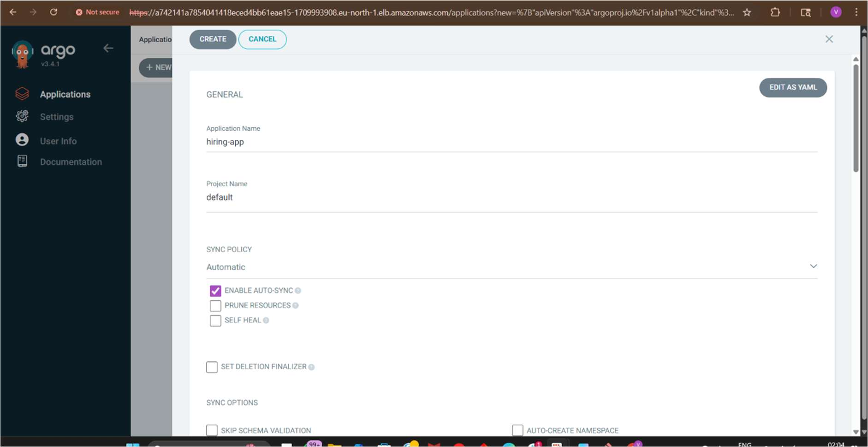

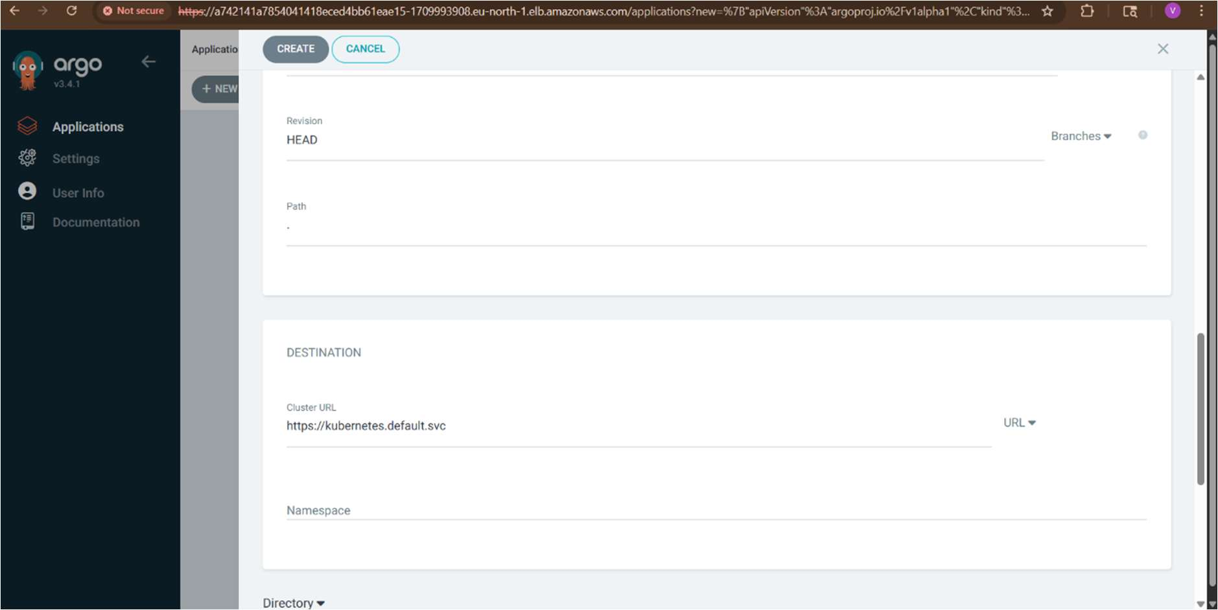
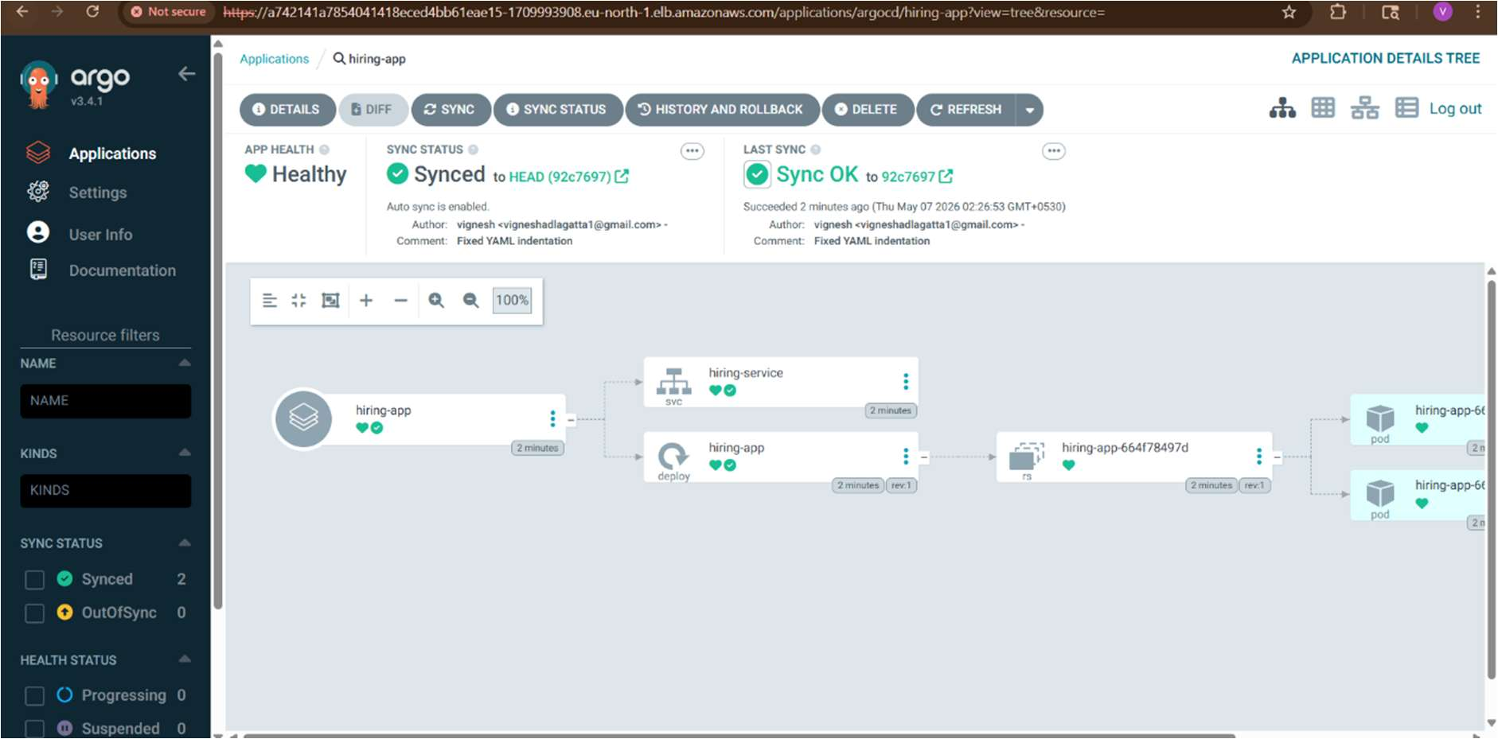

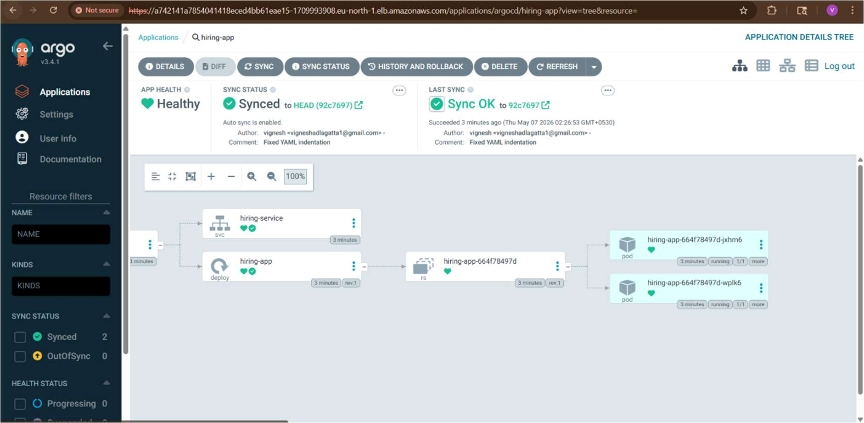
STEP 9: ArgoCD Deploys Automatically
ArgoCD now:
pulls manifests from GitHub
•
deploys to EKS
•
monitors drift
•
auto-syncs changes
•
STEP 10: Verify Deployment
Run:
kubectl get pods
kubectl get svc
You’ll see:
hiring-service
Copy EXTERNAL-IP.

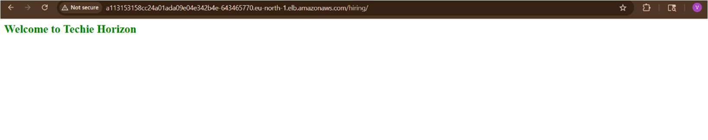

STEP 11: Open Application
Browser:
http://<LOADBALANCER-IP>
App deployed on EKS using ArgoCD.
Final GitOps Flow
Developer Pushes Code
↓
Jenkins Builds Docker Image
↓
Push To DockerHub
↓
Manifest Repo Updated
↓
ArgoCD Detects Change
↓
Deploys To EKS

